Heart and Circulatory System

About the Circulatory System
The heart and circulatory system (also called the cardiovascular system) make up the network that delivers blood to the body's tissues. With each heartbeat, blood is sent throughout our bodies, carrying oxygen and nutrients to all of our cells.
Every day, the approximately 5 liters of blood in your body travel many times through about 60,000 miles of blood vessels that branch and cross, linking the cells of our organs and body parts. From the hard-working heart, to our thickest arteries, to capillaries so thin that they can only be seen through a microscope, the cardiovascular system is our body's lifeline.
The circulatory system is composed of the heart and blood vessels, including arteries, veins, and capillaries. Our bodies actually have two circulatory systems: The pulmonary circulation is a short loop from the heart to the lungs and back again, and the systemic circulation (the system we usually think of as our circulatory system) sends blood from the heart to all the other parts of our bodies and back again.

The Heart
The heart is the key organ in the circulatory system. As a hollow, muscular pump, its main function is to propel blood throughout the body. In the average adult, it is about the size of a closed fist. It usually beats from 60 to 100 times per minute, but can go much faster when it needs to. It beats about 100,000 times a day, more than 30 million times per year, and about 2.5 billion times in a 70-year lifetime.
The heart gets messages from the body that tell it when to pump more or less blood depending on a person's needs. When we're sleeping, it pumps just enough to provide for the lower amounts of oxygen needed by our bodies at rest. When we're exercising or frightened, the heart pumps faster to get more oxygen to our bodies.
The heart has four chambers that are enclosed by thick, muscular walls. It lies between the lungs and just to the left of the middle of the chest cavity. The bottom part of the heart is divided into two chambers called the right and left ventricles, which pump blood out of the heart. A wall called the septum divides the ventricles.
The upper part of the heart is made up of the other two chambers of the heart, called the right and left atria (pronounced: ay-tree-uh). The right and left atria receive the blood entering the heart. The parts of the heart that open and close to control blood moving through it are called valves. Valves open to let blood move in, out, or between parts of the heart. The valves then close to keep the blood from moving in the wrong direction.

The Role of Blood Vessels
- Blood vessels carrying blood away from the heart are called arteries. They are the thickest blood vessels, with muscular walls that contract to keep the blood moving away from the heart and through the body. In the systemic circulation, oxygen-rich blood is pumped from the heart into the aorta. This huge artery curves up and back from the left ventricle, then heads down in front of the spinal column into the abdomen. Unlike the aorta, the body's other main artery, the pulmonary artery, carries oxygen-poor blood. From the right ventricle, the pulmonary artery divides into right and left branches, on the way to the lungs where blood picks up oxygen.
Right ventricle
Right atrium
Valves
Superior vena cava
Aorta
Left ventricle
Left atrium
Pulmonary veins
Pulmonary artery
Inferior vena cava
Septum

- Blood vessels that carry blood back to the heart are called veins. They are not as muscular as arteries, but they contain valves that prevent blood from flowing backward. The two largest veins are the superior and inferior vena cavae (pronounced: vee-nuh kay-vee). The terms superior and inferior do not mean that one vein is better than the other, but that they are located above (superior) and below (inferior) the heart.
- A network of tiny capillaries connects the arteries and veins. Even though they're tiny, the capillaries are one of the most important parts of the circulatory system because it is through them that nutrients and oxygen are delivered to the cells. In addition, waste products such as carbon dioxide are also removed by the capillaries.

What Do the Heart and Circulatory System Do?
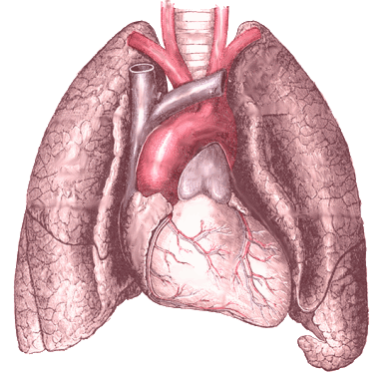
The circulatory system works closely with other systems in our bodies. It supplies oxygen and nutrients to our bodies by working with the respiratory system. At the same time, the circulatory system helps carry waste and carbon dioxide out of the body. Hormones — produced by the endocrine system — are also transported through the blood in our circulatory system. As the body's chemical messengers, hormones transfer information and instructions from one set of cells to another. The circulatory system also picks up the nutrients that are absorbed in the intestines and then deliver them to the cells around the body.
While in the capillaries, the bloodstream delivers oxygen and nutrients to the body's cells and picks up waste materials. Blood from the head and arms returns to the heart through the superior vena cava, and blood from the lower parts of the body returns through the inferior vena cava. Both vena cavae deliver this oxygen-depleted blood into the right atrium. From here the blood exits to fill the right ventricle, ready to be pumped into the pulmonary circulation for more oxygen.
In the pulmonary circulation, blood low in oxygen but high in carbon dioxide is pumped out the right ventricle into the pulmonary artery, which branches off in two directions. The right branch goes to the right lung, and vice versa. In the lungs, the branches divide further into capillaries. Blood flows more slowly through these tiny vessels, allowing time for gases to be exchanged between the capillary walls and the millions of alveoli (pronounced: al-vee-oh-lie), the tiny air sacs in the lung.

Things That Can Go Wrong With the Heart and Circulatory System
Problems with the cardiovascular system are common — more than 64 million Americans have some type of cardiac problem. But cardiovascular problems don't just affect older people — many heart and circulatory system problems affect teens, too.
Heart and circulatory problems are grouped into two categories: congenital, which means the problems were present at birth, and acquired, which means that the problems developed some time after birth.
Congenital heart defects. Congenital heart defects are heart problems that babies have at birth. Congenital heart defects occur while a baby is developing in the mother's uterus. Doctors don't always know why congenital heart defects occur — some congenital heart defects are caused by genetic disorders, but most are not. A common sign of a congenital heart defect is a heart murmur. A heart murmur is an abnormal sound (like a blowing or whooshing sound) that's heard when listening to the heart. Lots of kids and teens have heart murmurs, which can be caused by congenital heart defects or other heart conditions.
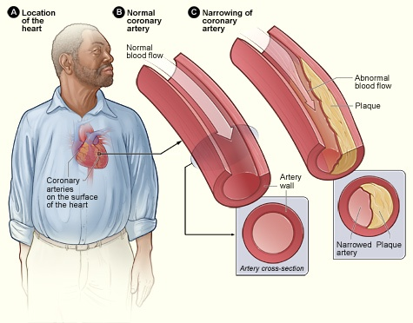
Coronary artery disease. Coronary artery disease is the most common heart disorder in adults, and it's caused by deposits of fat, calcium, and dead cells form on the inner walls and clog up the body's arteries — in this case, the coronary arteries (the blood vessels that supply the heart) — and get in the way of the smooth flow of blood. A clot of blood may even form, which can lead to a heart attack. Heart attacks are very rare in kids and teens.
Hypertension (high blood pressure). Hypertension is when a person has blood pressure that's significantly higher than normal. Over time, it can cause damage to the heart and arteries and other body organs. Teens can have high blood pressure, which may be caused by genetic factors, excess body weight, diet, lack of exercise, and diseases such as heart disease or kidney disease.
Reviewed by: Steven Dowshen, MD
Date reviewed: May 2010

