2.1 Forces change motion
Page 40D
- A force is a __________ or a ___________.
- Anytime you change motion of an object, you use a __________
Types of forces  (what is it, give examples) | Contact force:  Gravity:  Friction:
Force has…
Looking at the picture of the skater on page 42D | - What do the red arrows represent?  - What objects are gravity, friction, and contact forces acting upon?  - Would the forces shown be similar or different for a person walking?
Balanced and Unbalanced Forces | - Define NET FORCE:  - If forces on an object are balanced, what is the net force?  - Balanced forces have the ________ effect as ___________________.  - What kind of force changes the motion of an object?
Example  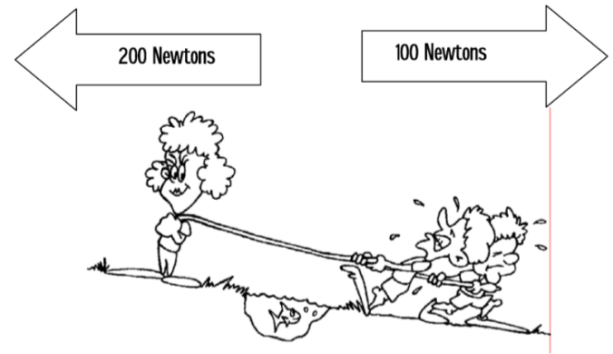 |  | Using the picture to the left…answer the following questions.  - Pushing or pulling force?  - Forces shown are acting in the same direction or different directions?  - Forces are equal or not equal?  - Forces are balanced or unbalanced?  - Motion is to the right or left?
Forces on moving objects. | - __________________ cannot change an object’s speed or its direction. An _____________________ is needed to change an object’s motion.  - Bike example:  - To increase the speed on a bike you must:  - To turn your bike you must:  - To stop the bike you must:  - What happens to a moving object if all the forces on it are balanced?
Newton’s first law relates force and motion.  Newton’s First Law states: | - How many laws of motion did Newton formulate?  - What had the ancient Greeks concluded about the motion of an object?  - Galileo’s experiment on friction concluded that:  - Friction is a force  - Objects at ________ and objects in ____________ both resist __________________________________________.  - Objects at rest tend to ______________________________.  - Objects in motion tend to ____________________________  - Unless ________________________________  How did Galileo’s ideas about objects in motion differ from those of the ancient Greeks?
Inertia | - Define inertia:  - Newton’s first law of motion is also called:  - Inertia is closely related to ___________.  - When you measure an objects ________, you are also measuring its _______________.  - Why is it easier to push/pull an empty box verses a box full of bricks? Explain in your own words.  - How do you measure an objects inertia?  If a car makes a sudden stop, what happens to a passenger riding in the back seat who is NOT wearing a seat belt?
Key Concepts | - Explain the difference between balanced and unbalanced forces?  - What is the relationship between for and motion descried by Newton’s first law?
2.2 Force and mass determine acceleration.
Page 49D
What three concepts are involved in Newton’s Second Law?
Newton’s Second Law | - States:  - What happens to the acceleration of an object when the force on it increases?  - A ping pong ball and a bowling ball are pushed with the same force. Which one will accelerate more? Why?
Force equals mass times acceleration | - Force = ___________ • ____________  - F =  - What is the standard unit of forces?  - What unit is used for mass when calculating force or acceleration?  - If the same force was applied to two objects of different mass, which object would have the greater acceleration?  - What formula is used to calculate acceleration?  - A mass of 2 kg. what other information do you need to calculate acceleration?
Mass and Acceleration | - Mass is also a variable in ________________________________.  - If the ___________________ acts on two objects, the object with _______________ will have the ________________acceleration.  - If an object ________ mass, they can gain _________________ if the force remains ____________________.
Use the sample problem found on page 53D to help solve the following problems | - Another model rocket is acceleration at a rate of 3 m/s² with a force of 1 N. What is the mass of the rocket?  - A boy pushes a shopping cart with a force of 10 N, and the cart accelerates 1 m/s². What is the mass of the cart?
Forces can change the direction of motion. | - If an object moves at a constant speed, but is accelerates, what changes?  - How can an object accelerate when it does not change speed?
Centripetal Force | - Define centripetal force:  - In what direction does centripetal force point?  - How does centripetal force change the motion of an object?  - How does increasing the centripetal force of an object affect its acceleration?  - What is the centripetal force that keeps the moon in orbit around Earth?
Key Concepts | - If the force acting upon an object is increased, what happens to the objects acceleration?  - How does the mass of an object affect its acceleration?  - What force is needed to accelerate an object 5 m/s² if the object has a mass of 10 kg?

