Name __________________________________ Date ___________ Page _____
Cells Test Study Guide
- What do all cells have in common? ________________________________________
- The smallest form of life and the most basic unit of all living organisms is the ________
- State the three most important parts of the cell theory.

- What is next in this series? Cells -> Tissues -> Organs -> ? _______________________
- A cell membrane is described as selectively permeable. What does this mean?
  - Will not allow any materials in or out of the cell
  - Will only allow water in or out of the cell
  - Will allow some materials in or out of the cell but will not allow other materials
  - Will allow all materials in or out of the cell

- It is important for materials to be able to move around the inside of a cell. Which organelle acts as a transportation system for these materials? ___________________
- E. coli is a dangerous bacteria that is one-celled and doesn’t have a nucleus. What kind of organism is E. coli? ____________________________________________________
- Complete the analogy: Rolesville MS is to a cell as lockers are to _________________
- A plant’s green color and its ability to make its own food by converting sunlight into energy are due to the presence of which organelle? ____________________________
- Which organelle is responsible for directing all of the activities of the cell? __________
- This organelle is a lot like a post office because it packages proteins and gets them ready to be delivered to other parts of the cell. ___________________________________
- Which organelle is most likely to assist in secretion or getting rid of materials? __________________________________________________________________
- What material helps keeps the organelles in place inside of the cell? _______________
- In order to find food and move from one location to another, the euglena uses a tail-like structure called a _____________________________________________________
- Which part of a cell determines the traits and ‘writes the laws’ of the cell? __________
- Cells need energy in order to do their jobs. Which organelle is responsible for breaking down glucose (sugar) to release energy for the cell? ___________________________
- Food cannot pass through the cell membrane until it has been completely broken down into a usable form. What is the usable form of food needed for energy?
  - Protein
  - Lipids
  - Cellulose
  - Glucose
- List the four different protists that we have studied, describe, and draw a picture.
Name | Description | Picture

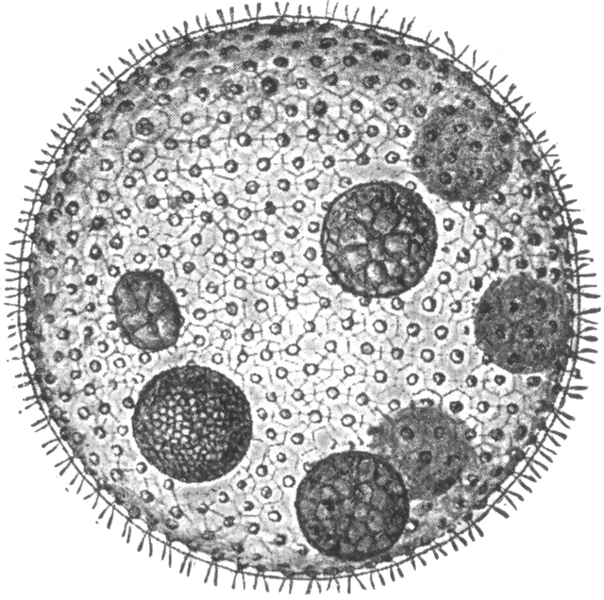
- List the type of structure each of the following use for movement.
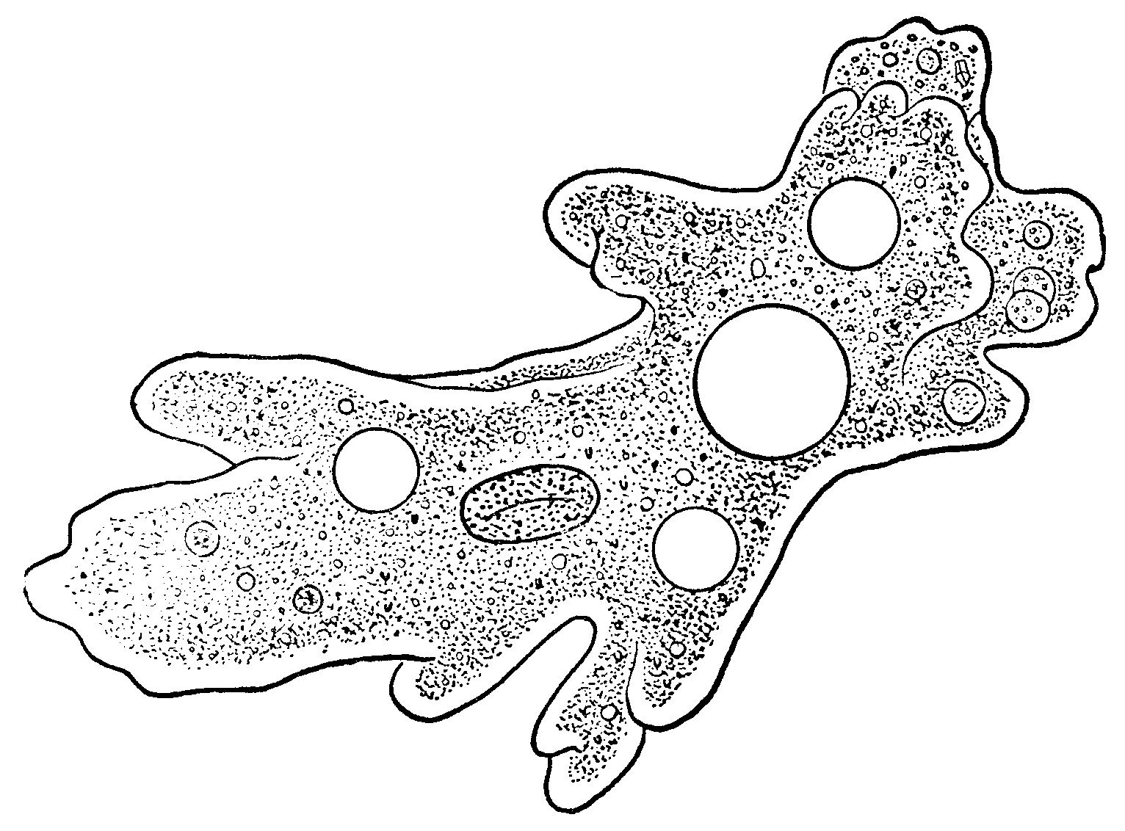
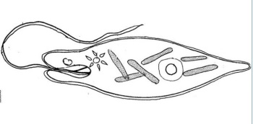
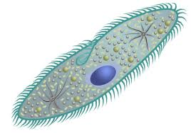

20. Compare and contrast plant and animal cells in the Venn Diagram below. You must include TWO items in EACH area of the Venn Diagram.
PLANT ANIMAL

21) List the levels of organization for all living multicellular organisms from the smallest unit to the whole organism. Describe and give an example of each level.
- List the type of structure each of the following use for movement.

20. Compare and contrast plant and animal cells in the Venn Diagram below. You must include TWO items in EACH area of the Venn Diagram.
PLANT ANIMAL

21) List the levels of organization for all living multicellular organisms from the smallest unit to the whole organism. Describe and give an example of each level.

