Anticipation Guide
Directions:
1. Respond to each statement below before the activity with a “T” for true or a “F” for false.
2. Complete the activity
3. Respond to each statement after the activity with a “T” for true or a “F” for false.
4. Rewrite the statements that are false so that they are true.
Before |  | After
 | 1. Force is anything that can make matter move or change. | F
 | 2. Electrical energy is produced through the interaction of charged particles. | T
 | 3. Energy transfer is when energy changes from one form to another. | T
 | 4. Electrical force is due to the pushing and pulling of electrons through an insulator. | F
 | 5. In order for electricity to be useful in our homes and for our devices, there must be a current and a insulator. | F
 | 6. A battery transforms chemical energy into electrical energy. | T
 | 7. Electricity made from a coal burning generator is an example of secondary energy. | T
 | 8. A waterfall used to power a generator is a type of green energy because it helps farmers and their crops. | F
Rewrite the false statements below:
1. Energy is anything that can make matter move or change.
4. Electrical force is due to the pushing and pulling of electrons through a circuit.
5. In order for electricity to be useful in our homes and for our devices, there must be a current and a complete circuit.
8. A waterfall used to power a generator is a type of green energy because it does not pollute the Earth.

Background Information
“Energy can mean lots of things. It’s everywhere! In physics, energy refers to the ability to do work usually that has something to do with movement, or action. Energy is anything that can make matter move or change. Energy comes in a number forms including:
*potential energy, which is energy that’s stored in a system and waiting to
come out;
*kinetic energy, which is the energy in a moving system;
*chemical energy, which is energy that’s stored in chemical bonds between
atoms;
*electrical energy, which is energy from interactions between charged
particles;
*thermal energy, which relates to heat energy of molecules;
*nuclear energy, which is energy that’s stored between the particles within
atoms.
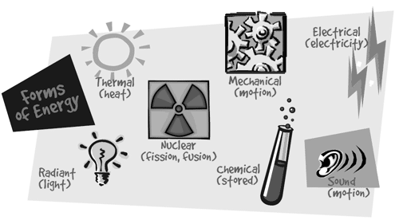
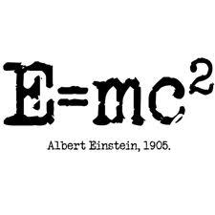
Light and other forms of electromagnetic radiation such as gamma rays or X-rays are also thought of as a form of energy. The physicist Albert Einstein showed that in fact, pretty much all mass is a form of energy too!”
(Source: brainpop.com)

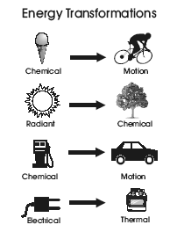
“The Law of Conservation of Energy states that energy cannot be created or destroyed in a system. Instead, it must be converted or transformed, into another type of energy. Energy transformation is when energy is changed from one form to another. You can see the idea of energy transformation when you think about lighting a match. What happens is that the chemical energy stored in the match is transformed into heat energy and light energy.” (Source: brainpop.com). When electrical energy passes through a light bulb, electrical energy is transformed into light energy.
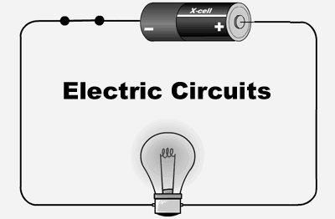
Energy can be transferred from one system to another when two objects push or pull on each other over a distance. In the case of electricity, electrons are pushed and pulled through a circuit.
“Electricity is the presence or movement of electrons, which are tiny, negatively charged particles that orbit an atom’s nucleus. Electricity is what we get when electrons move from one place to another. Electricity is naturally present in lightning and static electricity, but the flow of the electrons in lightning and static electricity are not controlled or steady. In order for electricity to be useful in our homes and devices, there needs to be a steady flow of electrons called a current. There also needs to be a complete circuit or a complete loop through which the electrical current can pass.
In a complete circuit, energy starts at a power source (for example a battery), moves through a conductor (for example, a metal wire), passes through a load (a device that uses electricity such as a light bulb or toaster) and returns back to the power source. It starts out in one place, travels around the circuit, and ends up back at the place where it originated. The electrons are pushed and pulled through the circuit.
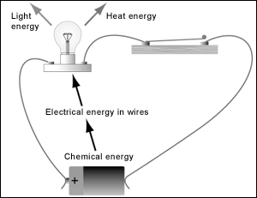
Batteries create an electrical force which can push and pull electrons through a complete circuit. Batteries are devices that use “energy transformation” to produce electricity. They work by changing stored chemical energy into electrical energy. A chemical reaction inside a battery creates electrons. Once created, the electrons are stored in one end of the battery, called the negative terminal (-). When a battery is part of a complete circuit, the negative terminal pushes the electrons out. The electrons travel from the negative terminal, through a conductor (metal wire), through a load (for example a
light bulb that transfers the electrical energy into light
energy) and back to the positive end of the battery
called the positive terminal (+). The positive side of
the battery pulls the electrons in.
A power plant uses a generator to produce electricity, specifically secondary energy. Primary energy is energy sources found in nature that have not been subjected to any conversion or transformation process such as wood, oil and natural gas. Secondary energy is energy which has been transformed from another source. To produce electricity through a generator, a heat source is needed to create the conditions in which electrical currents form. This heat can come from a variety of different primary energy sources including burning fossil fuels, water power, wind power and solar energy. Water, wind and solar power are sources of green energy—meaning they do not pollute the environment. Electricity is important because we can use it to make so many things work. Electrical energy can be transformed into light energy in light bulbs, sound energy in radios, heat energy in toasters, etc…
Sources:http://www.eia.gov/kids/ and Brainpop.com

Vocabulary
Word | Definition
Energy | The ability to do work. Anything that makes matter move or change.
Energy transformation | When energy is changed from one form to another. For example, electrical energy into light energy.
Force | A push or a pull.
Electrical Force | The pushing and pulling by moving electrons.
Electricity | The presence or movement of charged particles called electrons.
Electrical Energy | Energy from interactions between charged particles (electrons).
Current | A steady flow of electrons.
Circuit | The complete loop through which an electrical current can pass.
Green energy | Energy that comes from sources that do not pollute the Earth.
Primary Energy | Energy sources found in nature that have not been subjected to any conversion or transformation process.
Secondary Energy | Energy which has been transformed from another source.

Energy Transformation and Electric Circuits Lab
Materials: 2-3 miniature light bulbs, 2-3 miniature sockets, insulated wire, battery,
battery holder, switch, screwdriver (if wires do not have alligator clips).
Procedures:
1. Read the analysis questions.
2. Place a light bulb into a socket.
3. Place a battery in the battery holder.
4. Build a simple circuit by connecting the socket to the battery holder and to an open switch as shown below. Observe.
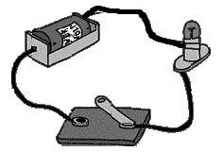
5. Close the switch. Observe.
6. Disconnect the wires.
7. Place two more light bulbs into two sockets (or one more if you do not have enough supplies). Build a series circuit by connecting the three sockets in a series with the battery and switch as shown below.
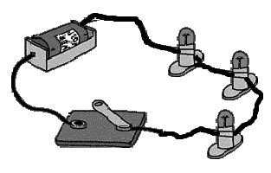
8. Close the switch. Observe.
9. Remove any one of the bulbs in the series circuit and observe.
Analysis:
1. Explain how and why opening and closing the switch affected the circuit.
2. Compare the brightness of the bulb in the simple circuit to the brightness of the bulbs in the series circuit? How is this related to the current?
3. What did you observe when you removed the light bulb in the series circuit? Why did this occur?
4. Draw a picture of the open simple circuit. Label areas where energy transfer occurs.
5. Draw a picture of the series circuit. Label areas where energy transfer occurs.
6. What will happen if any part of a circuit is disconnected? How does this relate to force?
7. Write a paragraph explaining the relationship between force, motion and electric circuits.
8. Compare the brightness of the lights in the series circuit to the parallel circuit. Why does this happen?
9. What happened when the circuit was set up in formation 4? Formation 5? Describe then explain why.

Science Reading for Success Passage One
Energy Sources
Source: http://www.eia.gov/kids/energy.cfm?page=about_home-basics

Energy Sources Can be Categorized As Renewable or Nonrenewable
When we use electricity in our home, the electrical power was probably generated by burning coal, by a nuclear reaction, or by a hydroelectric plant at a dam. Therefore, coal, nuclear and hydro are called energy sources. When we fill up a gas tank, the source might be petroleum or ethanol made by growing and processing corn.
Energy sources are divided into two groups — renewable (an energy source that can be easily replenished) and nonrenewable (an energy source that we are using up and cannot recreate). Renewable and nonrenewable energy sources can be used to produce secondary energy sources including electricity and hydrogen.

Renewable Energy
Renewable energy sources include:
- Solar energy from the sun, which can be turned into electricity and heat
- Wind
- Geothermal energy from heat inside the Earth
- Biomass from plants, which includes firewood from trees, ethanol from corn, and biodiesel from vegetable oil
- Hydropower from hydroturbines at a dam
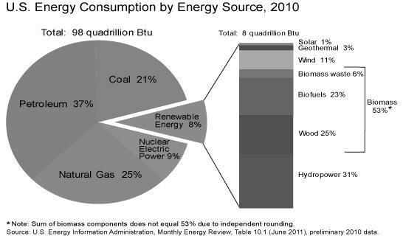

Nonrenewable Energy
We get most of our energy from nonrenewable energy sources, which include the fossil fuels — oil, natural gas, and coal. They're called fossil fuels because they were formed over millions and millions of years by the action of heat from the Earth's core and pressure from rock and soil on the remains (or "fossils") of dead plants and creatures like microscopic diatoms. Another nonrenewable energy source is the element uranium, whose atoms we split (through a process called nuclear fission) to create heat and ultimately electricity.
We use renewable and nonrenewable energy sources to generate the electricity we need for our homes, businesses, schools, and factories. Electricity "energizes" our computers, lights, refrigerators, washing machines, and air conditioners, to name only a few uses.
Most of the gasoline used in our cars and motorcycles and the diesel fuel used in our trucks are made from petroleum oil, a nonrenewable resource. Natural gas, used to heat homes, dry clothes, and cook food, is nonrenewable. The propane that fuels our outdoor grills is made from oil and natural gas, both nonrenewable.
The chart above shows what energy sources the United States used in 2010. Nonrenewable energy sources accounted for 92% of all energy used in the Nation. Biomass, the largest renewable source, accounted for over half of all renewable energy and 4% of total energy consumption.
Questions
1. Electricity is a secondary energy resource because……
A. it is made from another energy source.
B. it is the second most popular form of energy.
C. it can be transformed into other types of energy such as light in a lightbulb.
D. it is not truly a form of energy.
2. According to the circle graph in the reading, which of the following statements is true?
A. Most of the energy used by people in the United States is nonrenewable.
B. Solar energy is most often used in southern states such as Florida.
C. Nuclear energy is the cleanest form of energy.
D. Hydropower is the second most common type of renewable energy.
3. Fossil fuels………
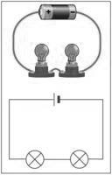
A. are made from fossils imprinted in rocks.
B. are formed through heat and pressure.
C. are important for hydroelectric cars.
D. can easily be replenished.

Science Reading for Success Passage 2
Electrical Circuits
By Brandi Waters (edhelper.com)
¹ You have already learned about electricity. You know that electricity is a stream of electrons moving from atom to atom. Electrons have a negative charge. They move toward atoms with a positive charge. When electrons move, electricity is made.
² Electrons cannot jump across a distance. There must be a path for electrons to follow. The path must be a series of atoms that can accept an electron. We call this path a circuit. People have learned how to build and manipulate circuits to move electricity. We use circuits to bring electricity into our homes. We use circuits to move electricity through our computers, telephones, toys, and even our cars.
³ Every time you flip a light switch in your house, you are using a circuit. The light bulb glows when electrons are flowing through it. The light bulb only glows when the switch is on. This is because the circuit is complete when the switch is on. Wiring in your house forms a path for electricity to flow. The wires are attached to the light bulb. The wires are also connected to the switch on the wall. When the switch is turned off, there is a break in the circuit. When the circuit is broken, electricity cannot flow through the light bulb. When the switch is turned on, the switch forms a bridge that completes the circuit. Electrons can flow through the wires, through the switch, and through the light bulb. The light bulb glows and lights your room. Circuits help people control when and where electricity flows.
1. Electricity is ______. Negatively charged A stream of electrons Made when electrons move from atom to atom All of the above | 2. What is used to make the circuits, or paths that electricity can flow through, in our homes? Switches Light bulbs Electrons Wires
3. People use electrical circuits to ______. Control where electricity flows and when it is flowing Control how much electricity is made Make electrons jump to positively charged atoms All of the above | 4. When a switch in an electrical circuit is turned off, ______. The electrical circuit is broken and electricity can not flow through

