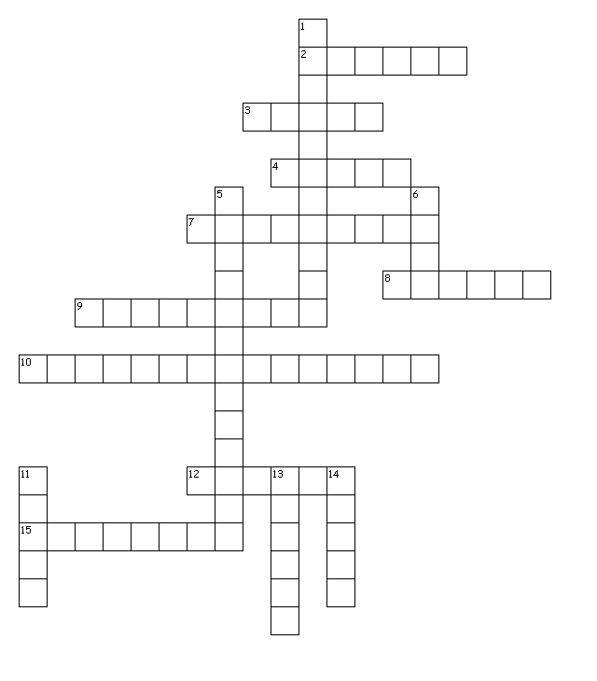**Circulatory System**

**Across**

2. one of the two chambers at the top of the heart that collects blood

3. blood vessels that move blood back to the heart

4. mostly liquid tissue that moves around body that delivers nutrients and oxygen; removes carbon dioxide and other wastes

7. one of the two chambers at the bottom of the heart that pumps blood

8. flaps in the heart that open and close to control the flow of blood

9. cells in the blood that help it clot at the sight of an injury

10. cells in the blood that fight bacteria, fungi, and viruses

12. mostly watery substance in water; also has salt, fats, hormones, and sugars

15. blood vessels that move blood away from the heart

**Down**

1. smallest blood vessels that allow gases and substances to move in and out of the blood

5. cells in the blood that carry oxygen and carbon dioxide

6. cava largest vein

11. muscle that pumps to move blood around the body

13. wall in the middle of the heart separating the right and left sides

14. largest artery