Move It! - Review
Newton’s Laws of Motion

- Newton’s 1st Law states that an object at rest tends to stay at ___rest____, and an object ___in motion__ tends to stay in motion, unless acted upon by an outside ____force______.

- Newton’s 2nd Law states that acceleration depends on ___mass____ and ___force_______.

- __Unbalanced___ forces cause an object to accelerate.

- Newton’s 3rd Law states that for every ___action______ there is a(n) __equal__ and ___opposite____ reaction.

- Force - ____a push or pull on an object____________________

- When two objects rub against each other it creates ___friction__.

Energy
- Energy is the ability to do ______work__________. Energy is anything that can make matter ____move____ or ________change________.

- __Stored energy__ is another word for potential energy.

- Kinetic energy is the energy an object has because of its ___motion_____.

- A skier at the top of a hill has this type of energy - __potential________.

- Energy _____transformation__ is the process of changing energy from one form to another.

- __Green energy____ – Energy that comes from sources that do not pollute the Earth.

- __Primary energy_____ – Energy sources found in nature that have not been subjected to any conversion or transformation process.

- ____Secondary Energy___ – Energy which has been transformed from another source.

- The complete loop through which an electrical current can pass is called a ____circuit______.

Simple Machines

Name | Graphic | Real World Example
Screw | 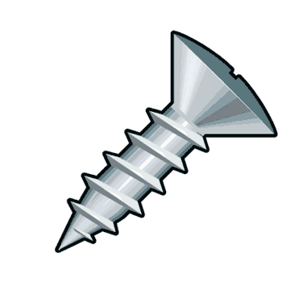 | Lid onto a jar  Lid onto a soda or water bottle
Inclined Plane | 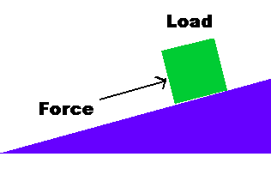 | Moving truck ramp
Wedge | 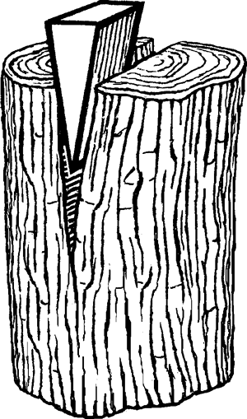 | Ax
Lever | 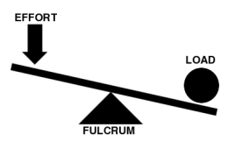 | Seesaw
Wheel & Axle |  | Ferris wheel, bike wheel, door knob
Pulley | 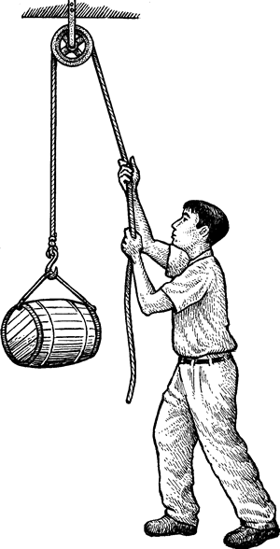 | Raising flag on flag pole  Raising flag on flag pole

MULTIPLE CHOICE

1 When does a roller coaster have the greatest potential energy?
a. When it is on the bottom of the first hill and about to go up the next hill.
b. When it is on the top of the first hill about to go down the first drop.
c. When it is half way up the second hill.
d. After the wheels and tracks are oiled.
2 Which of the following is an example of kinetic energy?
a. A slice of pizza
b. A ball rolling down a hill
c. A marine with a parachute is standing on the edge of an opened airplane door, ready to jump.
d. Gasoline in a car's fuel tank

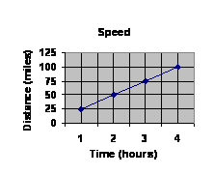
3 What is the average speed of the vehicle whose motion is shown in the graph after four hours of travel?

A 100 mph
B 25 mph
C 4 mph
D 50 mph
4 Which measurements do you need to calculate speed?
A | force and distance
B | time and force
C | distance and time
D | mass and velocity

5 As you were tracking a hurricane, you noticed that the velocity did not change for several hours. This means that the hurricane was
A | changing directions
B | accelerating quickly
C | not accelerating
D | getting larger

6 If a runner completes a 100 meter race in 20 seconds, what is her speed?
A | 5 meters per second (m/s)
B | 20 meters per second (m/s)
C | 10 meters per second (m/s)
D | 50 meters per second (m/s)

7 What two things do you need to know to describe the velocity of an object?
A | speed and direction
B | time and distance
C | speed and time
D | distance and direction

8 A car airbag slows the rate at which your body comes to a stop when the car stops suddenly in a collision. Which of the laws of motion best explains the need for an airbag?
A | For every action, there is an equal and opposite reaction
B | Objects in motion tend to stay in motion unless acted on by an outside force
C | An object's acceleration is dependent on its mass and the net force applied
D | Friction is a force that resists motion between two surfaces

9 If you are leaning against a wall, the wall is exerting
A | half of the force in the same direction
B | an equal force in the same direction
C | an equal force in the opposite direction
D | a force of 0 Newtons

10 What are electrons?
a. Negatively charged subatomic particles
b. Positively charged subatomic particles
c. Neutrally-charged subatomic particles
d. Negatively charged atoms

11 What is a current?
a. A steady flow of electricity
b. A short burst of electricity
c. A wire along which electricity flows
d. A power source that supplies electricity

12 How does alternating current differ from direct current?
a. Alternating current produces more voltage than direct current
b. Alternating current always flows in the same direction; the direction of a direct current switches back and forth
c. Direct current produces more voltage than alternating current
d. Direct current always flows in the same direction; the direction of an alternating current switches back and forth

13 What is one possible reason why it's a good idea to conserve electricity?
a. It is often produced by burning fossil fuels, which are a polluting, non-renewable resource
b. Power companies only give each home a limited amount of electricity every day
c. Using too much electricity can start dangerous electrical fires
d. Using too much electricity can cause power plants to break down

