Name _____________________________________________________ Date ___________ Page __________
Asexual and Sexual Reproduction
One parent or two? That is the main difference between sexual and asexual reproduction. Sexual reproduction just means combining genetic material from two parents. Asexual reproduction produces offspring genetically identical to the one parent.
Reproduction is the process by which organisms give rise to offspring. It is one of the defining characteristics of living things. There are two basic types of reproduction: asexual reproduction and sexual reproduction.
Asexual reproduction involves a single parent. It results in offspring that are genetically identical to each other and to the parent. All prokaryotes and some eukaryotes reproduce this way. There are several different methods of asexual reproduction. They include binary fission, fragmentation, and budding.
- Binary fission occurs when a parent cell splits into two identical daughter cells of the same size. Many bacteria reproduce this way.
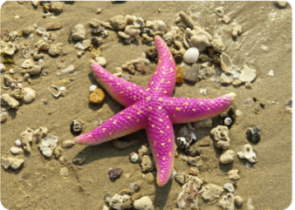
- Fragmentation occurs when a parent organism breaks into fragments, or pieces, and each fragment develops into a new organism. A new starfish can develop from a single ray, or arm. Starfish, however, are also capable of sexual reproduction.
- Budding occurs when a parent cell forms a bubble-like bud. The bud stays attached to the parent cell while it grows and develops. When the bud is fully developed, it breaks away from the parent cell and forms a new organism. Yeasts can create buds.
Asexual reproduction can be very rapid. This is an advantage for many organisms. It allows them to crowd out other organisms that reproduce more slowly. Bacteria, for example, may divide several times per hour. Under ideal conditions, 100 bacteria can divide to produce millions of bacterial cells in just a few hours! However, most bacteria do not live under ideal conditions. If they did, the entire surface of the planet would soon be covered with them. Instead, their reproduction is kept in check by limited resources, predators, and their own wastes. This is true of most other organisms as well. Organisms that reproduce asexually cannot develop much variety, because they are "copying" the original organism almost exactly.

Sexual reproduction involves two parents. Sexual reproduction allows for great diversity, because the offspring is different from the mother's egg and father's sperm; it is a combination of both. Sexual reproduction produces a greater chance of variation within a species than asexual reproduction would. This variation improves the chances that a species will adapt to his environment and survive. The larger organ systems and complex brain of larger organisms allows them to adapt to their environment and increases their chances of survival.

Sexual reproduction takes longer as the female has to grow eggs, fertilization then occurs, and then the offspring need to develop before being born or hatched. Just think, the pregnancy of African elephants lasts an average of 660 days! Diversity or variation in sexual reproduction is guaranteed because the genetic information from two parents is combined randomly. No two offspring from a set of parents will ever have the same combination of genes. Identical twins are a unique situation but even then differences can exist. Sexual reproduction requires an egg cell from the female parent and a sperm cell from the male parent; each of these cells contains copies of ½ of the parents’ genes. When these two cells combine, fertilization occurs and a new cell is created.
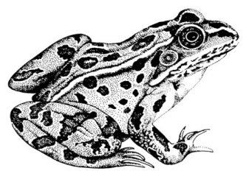
Large mammals such as gorillas, dolphins, and kangaroos all reproduce sexually. Frogs and fish have sexual reproduction, but it is done externally. The female lays eggs and the male fertilizes the eggs by squirting sperm in the water. Turtles and birds also lay eggs, but fertilization has already occurred internally.

A little bit of both? Many plants and some smaller animals can reproduce both ways. Plants can create fertilized seeds that combine parts of the male and female cells (sexual). Plants also can sprout new plants through the root systems that separate after the new plant begins to grow (asexual). Animals such as worms, starfish, and jellyfish can also reproduce both ways. If the animals are separated from the rest of the population or need to increase the chances of finding a mate, they can make copies of themselves (asexual). Otherwise, they reproduce with another organism like most other animals (sexual).
Characteristics of Asexual Reproduction | Characteristics of Sexual Reproduction
Conclusion:
- Why can’t larger organisms reproduce asexually?

- What do the two types of reproduction have in common?

- What are the advantages of asexual reproduction?

- What are the advantages of sexual reproduction?

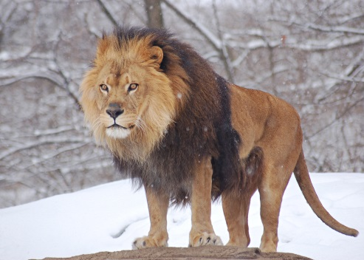  Lion | 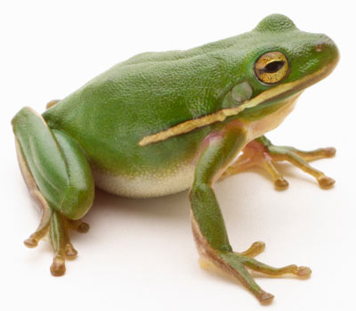  Frog | 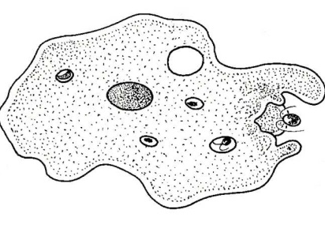  Amoeba | 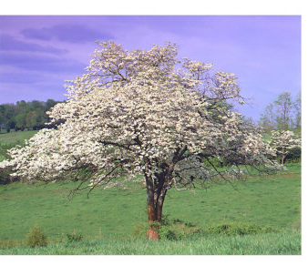  Tree
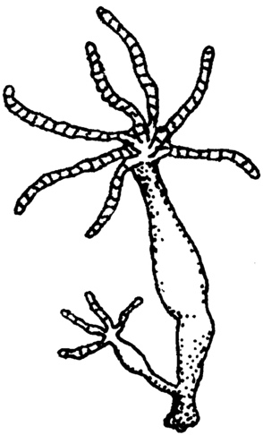  Hydra | 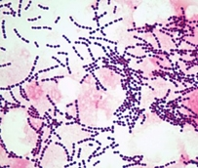  Strep bacteria | 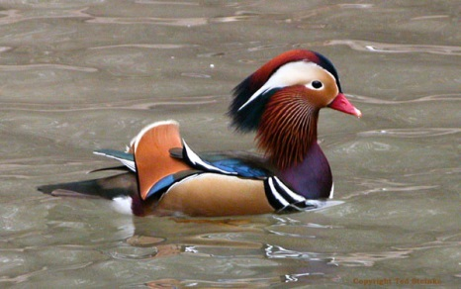  Duck | 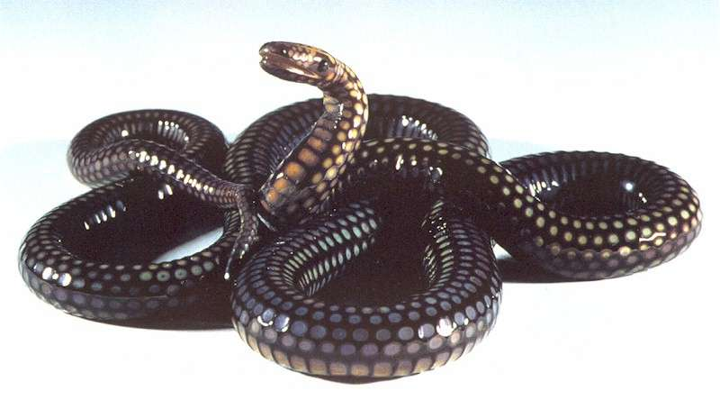  Snake
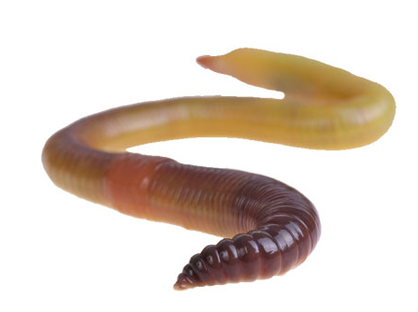  Worm | 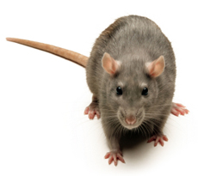  Rat | 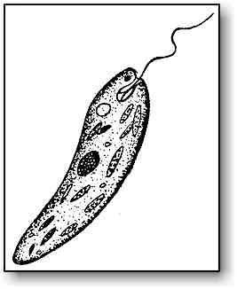  Euglena | 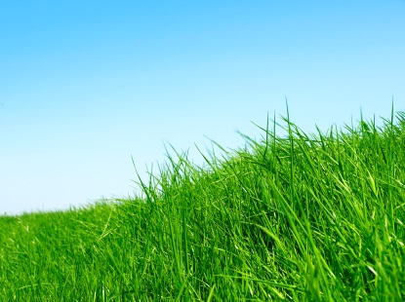  Grass

