Fill in the blanks below with words from this box:
evaporation  evaporates  heating  droplets  runoff  rain | sunny  clouds  heavy  plants  snow  rivers |  | precipitate  vapor  oceans  hail  cycle  streams | condenses  atmosphere  lakes  glaciers  crystals
Evaporation
On a warm, __________________ day, water in a glass of water seems to slowly disappear. This is because the energy from the sun is _______________ the water up and turning the liquid water into water ______________. This process is called ___________________. When the water ________________, it becomes an invisible gas in the _____________________. Evaporation takes places all over the earth, but especially in the ________________ and ________________ where there is lots of water.

Condensation
As the water vapor rises, it cools off and ______________________ into water _________________. If the water vapor becomes extremely cold, it will form ice ________________ instead of water droplets. As the water droplets or ice crystals grow bigger and more numerous, they form ___________________.

Precipitation
If water droplets or ice crystals become too _______________, they can’t stay in the air. They _________________. Water droplets precipitate as ________________ and ice crystals precipitate as _________________. Sometimes, the rain freezes before it hits the earth and precipitates as _________________.
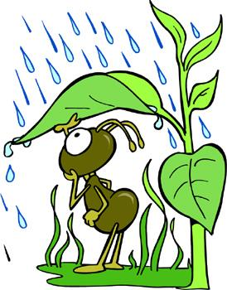 |  | Runoff  This precipitation gathers into ________________ and _________________ that flow down to the lakes and oceans. This is called __________________. Not all of the water makes it back to the oceans and lakes right away. Some of it is used by animals and ________________. Some is frozen into ___________________. Eventually, the animals and plants breathe the water out and the glaciers melt, releasing the water back into the water _______________.

© 2006 www.bogglesworldesl.com

