Reproductive System
Ever wonder how the universe could allow the existence of someone as annoying as your bratty little brother or sister? The answer lies in reproduction. If people — like your parents (ew!) — didn't reproduce, families would die out and the human race would cease to exist.

Reproduction
All living things reproduce. Reproduction — the process by which organisms make more organisms like themselves — is one of the things that set living things apart from nonliving matter. But even though the reproductive system is essential to keeping a species alive, unlike other body systems, it's not essential to keeping an individual alive.
In the human reproductive process, two kinds of sex cells, or gametes (pronounced: gah-meetz), are involved. The male gamete, or sperm, and the female gamete, the egg, meet in the female's reproductive system to create a new individual. Both the male and female reproductive systems are essential for reproduction. The female needs a male to fertilize her egg, even though it is she who carries offspring through pregnancy and childbirth.
Humans, like other organisms, pass certain characteristics of themselves to the next generation through their genes, the special carriers of human traits. The genes that parents pass along to their children are what make children similar to others in their family, but they are also what make each child unique. These genes come from the father's sperm and the mother's egg, which are produced by the male and female reproductive systems. Because these genes combine in random in different arrangements, each person will look, think, and act in an unique way.

Female Reproductive System

What Is the Female Reproductive System?

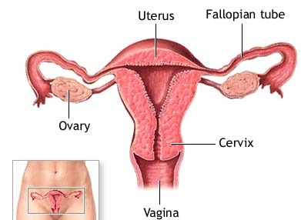
Most species have two sexes: male and female. Each sex has its own unique reproductive system. They are different in shape and structure, but both are specifically designed to produce, nourish, and transport either the egg or sperm.
Unlike the male, the human female has a reproductive system located entirely in the pelvis (that's the lowest part of the abdomen). A female's internal reproductive organs are the vagina, uterus, fallopian tubes, and ovaries.
The vagina is a muscular, hollow tube that extends from the vaginal opening to the uterus. The vagina is about 3 to 5 inches (8 to 12 centimeters) long in a grown woman. Because it has muscular walls it can expand and contract. The vagina has several functions: for sexual intercourse and as the pathway that a baby takes out of a woman's body during childbirth.
The uterus is shaped like an upside-down pear, with a thick lining and muscular walls — in fact, the uterus contains some of the strongest muscles in the female body. These muscles are able to expand and contract to accommodate a growing fetus and then help push the baby out during labor. When a woman isn't pregnant, the uterus is only about 3 inches (7.5 centimeters) long and 2 inches (5 centimeters) wide.
At the upper corners of the uterus, the fallopian (pronounced: fuh-lo-pee-un) tubes connect the uterus to the ovaries (pronounced: o-vuh-reez). The ovaries are two oval-shaped organs that lie to the upper right and left of the uterus. They produce, store, and release eggs into the fallopian tubes in the process called ovulation (pronounced: av-yoo-lay-shun). Each ovary measures about 1½ to 2 inches (4 to 5 centimeters) in a grown woman.
The ovaries are also part of the endocrine system because they produce female sex hormones such as estrogen (pronounced: es-truh-jun) and progesterone (pronounced: pro-jes-tuh-rone). The ovaries store egg cells through the course of a female’s lifetime. Females are born with all of the eggs they will ever produce. As the female reaches puberty, hormones are released by the body that makes these eggs begin to mature and then release from the ovaries.

What Does the Female Reproductive System Do?
The female reproductive system enables a woman to:
- produce eggs (ova)
- have sexual intercourse
- protect and nourish the fertilized egg until it is fully developed
- give birth

Male Reproductive System

What Is the Male Reproductive System?
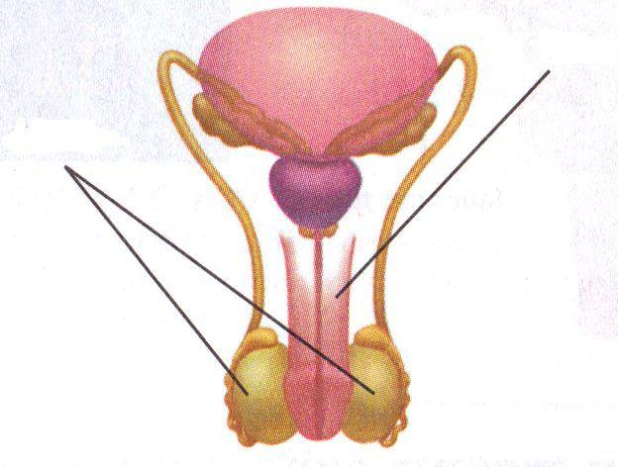
penis
testicles (testes)

scrotum

In a guy who's reached sexual maturity, the two testicles (pronounced: tes-tih-kulz), or testes (pronounced: tes-teez), produce and store millions of tiny sperm cells. The testicles are oval-shaped and grow to be about 2 inches (5 centimeters) in length and 1 inch (3 centimeters) in diameter. The testicles are also part of the endocrine system because they produce hormones, including testosterone (pronounced: tes-tos-tuh-rone). Testosterone is a major part of puberty in guys, and as a guy makes his way through puberty, his testicles produce more and more of it. Testosterone is the hormone that causes guys to develop deeper voices, bigger muscles, and body and facial hair, and it also stimulates the production of sperm. The sperm are created in the testicles throughout a male’s lifetime. Sperm are the smallest types of cells in the human body and move great distances to reach the egg of a female during sexual intercourse.
The testicles hang in a pouch-like structure outside the pelvis called the scrotum. This bag of skin helps to regulate the temperature of testicles, which need to be kept cooler than body temperature to produce sperm. The scrotum changes size to maintain the right temperature. When the body is cold, the scrotum shrinks and becomes tighter to hold in body heat. When it's warm, the scrotum becomes larger to get rid of extra heat. This happens without a guy ever having to think about it.
The penis is an organ which works as part of the urinary and reproductive system. The penis is the means by which males release urine from the bladder and semen during sexual intercourse. Semen is a liquid mixture of sperm, seminal fluid, fructose, and other substances that support the sperm.

What Does the Male Reproductive System Do?
The male sex organs work together to produce and release semen into the reproductive system of the female during sexual intercourse. The male reproductive system also produces sex hormones, which help a boy develop into a sexually mature man during puberty.
When the male ejaculates during intercourse, semen is deposited into the female's vagina. From the vagina the sperm make their way up through the cervix and move through the uterus with help from uterine contractions. If a mature egg is in one of the female's fallopian tubes, a single sperm may penetrate it, and fertilization, or conception, occurs.
This fertilized egg is now called a zygote (pronounced: zy-goat) and contains 46 chromosomes — half from the egg and half from the sperm. The genetic material from the male and female has combined so that a new individual can be created. The zygote divides again and again as it grows in the female's uterus, maturing over the course of the pregnancy into an embryo, a fetus, and finally a newborn baby.
Fertilization and Pregnancy

Once an egg has been fertilized, it quickly begins to grow once it reaches the uterus in the female. The cell multiplies thousands of times and move to new positions to eventually become the embryo (pronounced: em-bree-o). After approximately 8 weeks, the embryo is about the size of an adult's thumb, but almost all of its parts — the brain and nerves, the heart and blood, the stomach and intestines, and the muscles and skin — have formed.
During the fetal stage, which lasts from 9 weeks after fertilization to birth, development continues as cells multiply, move, and change. The fetus (pronounced: fee-tus) floats in amniotic (pronounced: am-nee-ah-tik) fluid inside the amniotic sac. The fetus receives oxygen and nourishment from the mother's blood via the placenta (pronounced: pluh-sen-tuh), a disk-like structure that sticks to the inner lining of the uterus and connects to the fetus via the umbilical (pronounced: um-bih-lih-kul) cord. The amniotic fluid and membrane cushion the fetus against bumps and jolts to the mother's body. During this stage, the baby’s gender can be determined, the organs finish developing, and the baby begins to move.
Pregnancy lasts an average of 280 days — about 9 months. When the baby is ready for birth, its head presses on the cervix, which begins to relax and widen to get ready for the baby to pass into and through the vagina. The mucus that has formed a plug in the cervix loosens, and with amniotic fluid, comes out through the vagina when the mother's water breaks. Strong muscle contractions in the mother’s abdomen work automatically to help the female push the baby through the birth canal. A female’s labor has three stages and can last a few hours or even days.
The Menstrual Cycle
Egg development in the ovaries is controlled by a series of hormones which also cause changes in a female’s uterus. The cycle of egg growth and release happens every 28 days and is referred to as the menstrual cycle. When a female begins to develop mature eggs, a surge of hormones causes one egg to be released from the ovaries. This is called ovulation. Meanwhile, hormones also cause the lining of the uterus to thicken in preparation to house the egg in the event it is fertilized by a sperm cell. If the egg is not fertilized, the extra lining is then shed in a process called menstruation. The cycle then begins again with another cell growing to maturity.

The Menstrual Cycle
