Name __________________________________ Date ___________ Page _____
Circulatory System
What is the circulatory system made up of?
What is the different between the pulmonary and the systemic circulatory systems?
What are three important statistics about the heart?
Label the parts of the heart:  Left ventricle  Right ventricle  Left atrium  Right atrium  Septum  Valves  Aorta  Pulmonary arteries  Pulmonary veins  Sup. vena cava  Inf. vena cava | 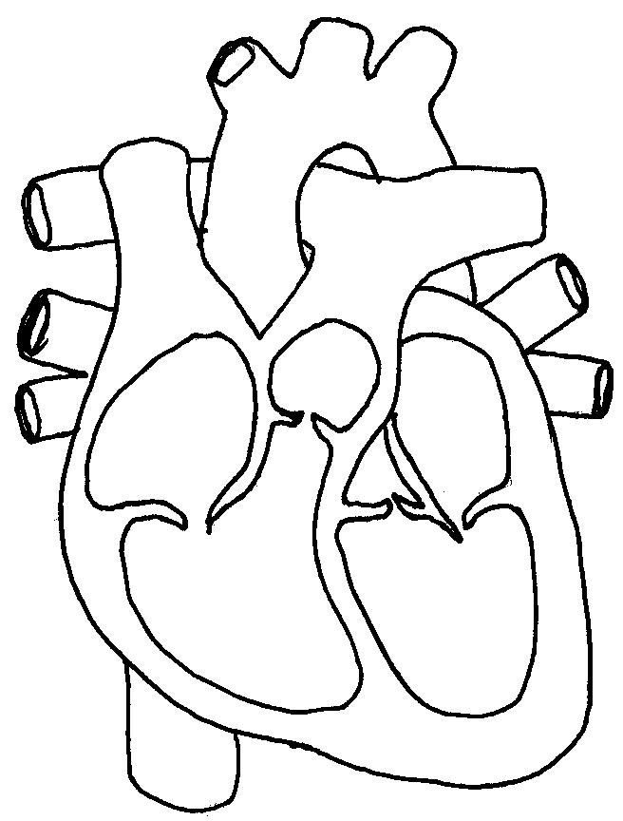
Define the three types of blood vessels.
Why do you think there are separate blood vessels for blood going to and from the lungs?
How does the circulatory system work with the other systems of the body?
Create an illustration that shows the direction blood flows through the body. Don’t forget the lungs!
Define three heart problems.

