Name __________________________________ Date ___________ Page _____
Ozone: Good Up High, Bad Nearby
The Earth is wrapped in a blanket of air called the 'atmosphere', which is made up of several layers. About 19-30 kilometres (11-18 miles) above the Earth is a layer of gas called ozone, which is a form of oxygen. Ozone is produced naturally in the atmosphere.
WHY DO WE HAVE AN OZONE LAYER?
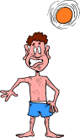
The ozone layer is very important because it stops too many of the sun's 'ultra-violet rays' (UV rays) getting through to the Earth - these are the rays that cause our skin to tan. Too much UV can cause skin cancer and will also harm all plants and animals. Life on Earth could not exist without the protective shield of the ozone layer.
WHAT IS THE OZONE HOLE?
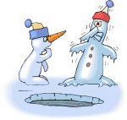
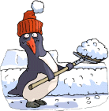
Every spring, a hole as big as the USA develops in the ozone layer over Antarctica, in the South Pole. A smaller hole develops each year over the Arctic, at the North Pole. And there are signs that the ozone layer is getting thinner all over the planet.
Scientists have discovered that the ozone hole over Antarctica started in 1979, and that the ozone layer generally started to get thin in the early 1980s.
The loss of the ozone layer occurs when more ozone is being destroyed than nature is creating.
WHAT CAUSES THE OZONE HOLE?
One group of gases is particularly likely to damage the ozone layer. These gases are called CFCs, Chloro-Fluoro-Carbons.
CFCs are used in some spray cans to force the contents out of the can.
They are also used in refrigerators, air conditioning systems and some fire extinguishers. They are used because they are not poisonous and do not catch fire.
Most countries have now stopped using new CFCs that can be released into the atmosphere, but many scientists believe we must stop using old ones as well.
THE OZONE HOLE AND OUR HEALTH
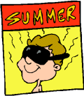
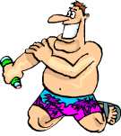
The ozone layer is like a sunscreen, and a thinning of it would mean that more ultra-violet rays would be reaching us.
Too many UV rays would cause more sunburn, and because sunburn causes skin cancer, this too would increase deaths.
These UV rays are also dangerous for our eyes and could cause an increase in people becoming blind. That is why sun cream and sunglasses are very important.
THE OZONE HOLE ON ANIMALS AND PLANTS
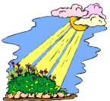
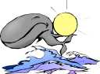
UV rays can go through water and end up killing small water animals or plants, called 'plankton' which form the base of the food chain in oceans and seas. Whales and other fishes have plankton as their main food, and if plankton die because of these UV rays, whales will start dying too, because they will not have anything to eat. Large amounts of UV rays could damage all green plants. If the ozone layer keeps getting thinner, there could be fewer and fewer plants on Earth, then there would be less food in the whole world.
THE TWO-FACED OZONE GAS
Ozone found “Up High” in the atmosphere is one of the reasons why we are alive on Earth. In addition to blocking UV rays from the sun, ozone is one of many gases known as greenhouse gases. These gases help trap the sun’s heat to keep Earth warm.
But when the gas ozone is found lower or “Nearby” where we can breathe it in, it becomes very dangerous for our health. This ozone is caused by a reaction between air pollution and sunlight and can cause modern-day smog. This is different to the smog that formed in the early 20th century from smoke and fog.

Summarization Pyramid
Topic:

Syno
Ozone is…
Ozone is NOT…
Two new vocabulary words I learned were…(write the definitions in the margins of this paper)
With this topic, I was most interested in…
One idea of my own about this topic is…
Three important characteristics about this topic are:
One thing I want to know more about is…

The most important thing to remember about this topic is…

