CELLabration Time! – Review
- Single-Celled Pond Organisms
Image | Organism’s Name | Structure | Movement | Food Source
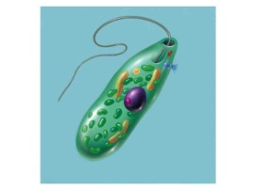 | Euglena | Oval shaped; has an eyespot | Moves using flagella | autotroph & heterotroph
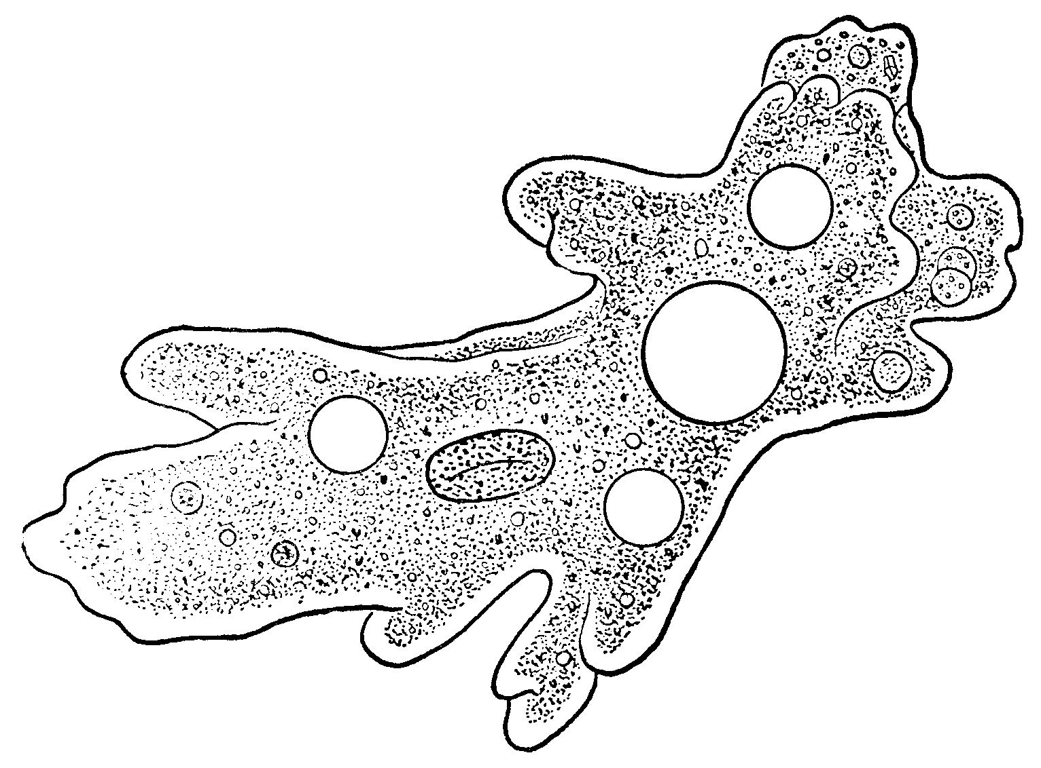 | Amoeba | Shapeless; has pseudopods (finger-like projections) | Moves using pseudopodia | heterotroph
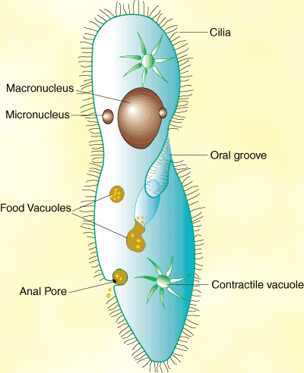 | Paramecium | Oval, slipper-shaped; rounded front & pointed back | Moves using cilia | heterotroph
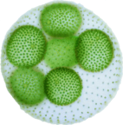 | Volvox | Round, several make a colony; green algae; have an eyespot | Moves using flagella | autotroph

- Plant & Animal Cells

Name of Organelle | Location  (plant, animal, both) | Structure  (Description) | Function  (Job)
Nucleus | Both | Rounded shape surrounded by rest of organelles | Controls the cells’ activities
Nucleolus | Both | Small, spherical structure inside the nucleus | Produces ribosomes
Cell Membrane | Both | Plant – inside cell wall  Animal – outer layer | Controls what comes in and out of the cell
Cytoplasm | Both | Clear gel-like fluid | Home to cell’s organelles  (holds them)
Ribosomes | Both | Small bodies floating free or attached to the endoplasmic reticulum | Produces proteins
Mitochondria | Both | Bean shaped with inner membrane | Break down sugar molecules to create energy
Vacuole | Both | Fluid-filled sacs | Storage area for cells
Golgi Bodies | Both | Flattened sacs or tubes | Receives protein & other materials from ER, packages & redistributes them
Endoplasmic Reticulum | Both | Network of folded tubes or membranes | Carries protein and other materials from one part of the cell to another
Lysosomes | Plant cells- uncommon  Animal cells- common | Small round structures | Use chemicals to break down large food particles into smaller ones & breaks down old cells
Cell Wall | Plant Cells Only | outer layer, rigid, strong, stiff, non-living | protects & supports cell  *allows oxygen and water to pass through
Chloroplast | Plant Cells Only | Green, oval structures usually containing chlorophyll | Captures energy from sunlight & uses it to produce food for cells

- Multicellular Organisms – Hierarchical Organization
Cells, Tissue, Organs, Organ Systems, Organism
CELLabration Time! – Review
- Which of the following statements is part of the cell theory?
a. | Only plants are composed of cells.
b. | All cells are produced from other cells.
c. | Cells can be produced from nonliving matter.
d. | Cells are one of several basic units of structure and function in living things.
- Mitosis is the process by which
a. | toes become diseased.
b. | cells die.
c. | a cell divides.
d. | muscles become strained.

- Specialized cells are found only in
a. | animals.
b. | single-celled organisms.
c. | bacteria.
d. | multi-cellular organisms.
- Which of the following best describes the function of mitochondria?
a. | They convert energy from food molecules into energy the cell can use.
b. | They store energy from food molecules.
c. | They store energy from sunlight.
d. | They produce nucleic acids that release energy.
- All plants are
a. | eukaryotes.
b. | unicellular.
c. | heterotrophs.
d. | prokaryotes.
- What type of organism is a paramecium?
- Unicellular
- Multicellular
- Acellular
- prokaryote

