Digestive System

Food Is the Body's Fuel Source
What's the first step in digesting food? Believe it or not, the digestive process starts even before you put food in your mouth. It begins when you smell something irresistible or when you see a favorite food you know will taste good. Just by smelling that homemade apple pie or thinking about how delicious that ice cream sundae is going to taste, you begin to salivate — and the digestive process kicks in, preparing for that first scrumptious bite.
If it's been a while since your last meal or if you even think about something tasty, you feel hungry. You eat until you're satisfied and then go about your business. But for the next 20 hours or so, your digestive system is doing its job as the food you ate travels through your body.
Food is the body's fuel source. The nutrients in food give the body's cells the energy and other substances they need to operate. But before food can do any of these things, it has to be digested into small pieces the body can absorb and use.
Almost all animals have a tube-type digestive system in which food enters the mouth, passes through a long tube, and exits as feces (poop) through the anus. The smooth muscle in the walls of the tube-shaped digestive organs rhythmically and efficiently moves the food through the system, where it is broken down into tiny absorbable nutrients.
During the process of absorption, nutrients that come from the food (including carbohydrates, proteins, fats, vitamins, and minerals) pass through channels in the intestinal wall and into the bloodstream. The blood works to distribute these nutrients to the rest of the body. The waste parts of food that the body can't use are passed out of the body as feces.

What Is the Digestive System?
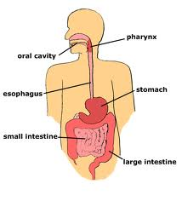
Every morsel of food we eat has to be broken down into nutrients that can be absorbed by the body, which is why it takes hours to fully digest food. In humans, protein must be broken down into amino acids, starches into simple sugars, and fats into fatty acids and glycerol. The water in our food and drink is also absorbed into the bloodstream to provide the body with the fluid it needs.
The digestive system is made up of the alimentary canal and the other abdominal organs that play a part in digestion, such as the liver and pancreas. The alimentary canal (also called the digestive tract) is the long tube of organs — including the esophagus, the stomach, and the intestines — that runs from the mouth to the anus. An adult's digestive tract is about 30 feet long.

How Does Digestion Work?

Digestion Begins in the Mouth
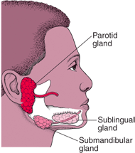
The process of digestion starts well before food reaches the stomach. When we see, smell, taste, or even imagine a tasty snack, our salivary glands, which are located under the tongue and near the lower jaw, begin producing saliva. This flow of saliva is set in motion by a brain reflex that's triggered when we sense food or even think about eating. In response to this sensory stimulation, the brain sends impulses through the nerves that control the salivary glands, telling them to prepare for a meal.
As the teeth tear and chop the food, saliva moistens it for easy swallowing. A digestive enzyme called amylase (pronounced: ah-meh-lace), which is found in saliva, starts to break down some of the carbohydrates (starches and sugars) in the food even before it leaves the mouth.
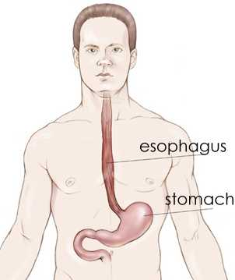
Swallowing, which is accomplished by muscle movements in the tongue and mouth, moves the food into the throat, or pharynx. The pharynx (pronounced: fair-inks), a passageway for food and air, is about 5 inches long. A flexible flap of tissue called the epiglottis (pronounced: ep-ih-glah-tus) reflexively closes over the windpipe when we swallow to prevent choking.
From the throat, food travels down a muscular tube in the chest called the esophagus (pronounced: ih-sah-fuh-gus). Waves of muscle contractions called peristalsis (pronounced: per-uh-stall-sus) force food down through the esophagus to the stomach. A person normally isn't aware of the movements of the esophagus, stomach, and intestine that take place as food passes through the digestive tract.

The Stomach
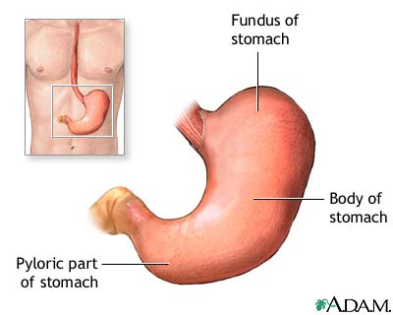
At the end of the esophagus, a muscular ring called a sphincter (pronounced: sfink-ter) allows food to enter the stomach and then squeezes shut to keep food or fluid from flowing back up into the esophagus. The stomach muscles churn and mix the food with acids and enzymes, breaking it into much smaller, more digestible pieces. An acidic environment is needed for the digestion that takes place in the stomach. Glands in the stomach lining produce about 3 quarts of these digestive juices each day.
Most substances in the food we eat need further digestion and must travel into the intestine before being absorbed. When it's empty, an adult's stomach has a volume of one fifth of a cup, but it can expand to hold more than 8 cups of food after a large meal.
By the time food is ready to leave the stomach, it has been processed into a thick liquid called chyme (pronounced: kime). A walnut-sized muscular tube at the outlet of the stomach called the pylorus (pronounced: py-lore-us) keeps chyme in the stomach until it reaches the right consistency to pass into the small intestine. Chyme is then squirted down into the small intestine, where digestion of food continues so the body can absorb the nutrients into the bloodstream.

How Does Digestion Work? (cont.)

The Small Intestine
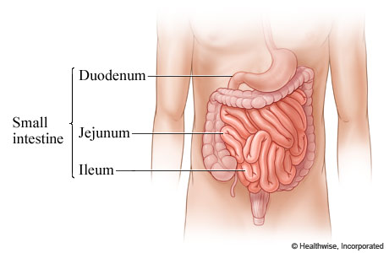
The small intestine is made up of three parts:
- the duodenum (pronounced: due-uh-dee-num), the C-shaped first part
- the jejunum (pronounced: jih-ju-num), the coiled midsection
- the ileum (pronounced: ih-lee-um), the final section that leads into the large intestine
The inner wall of the small intestine is covered with millions of microscopic, finger-like projections called villi (pronounced: vih-lie). The villi are the vehicles through which nutrients can be absorbed into the body.

The Liver
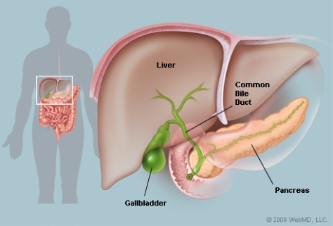
The liver (located under the ribcage in the right upper part of the abdomen), the gallbladder (hidden just below the liver), and the pancreas (beneath the stomach) are not part of the alimentary canal, but these organs are still important for healthy digestion.
The pancreas produces enzymes that help digest proteins, fats, and carbohydrates. It also makes a substance that neutralizes stomach acid. The liver produces bile, which helps the body absorb fat. Bile is stored in the gallbladder until it is needed. These enzymes and bile travel through special channels (called ducts) directly into the small intestine, where they help to break down food.
The liver also plays a major role in the handling and processing of nutrients. These nutrients are carried to the liver in the blood from the small intestine.

The Large Intestine
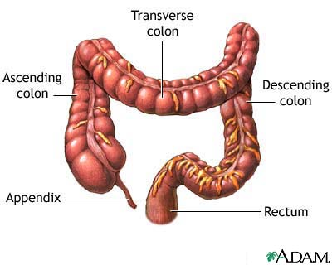
From the small intestine, food that has not been digested (and some water) travels to the large intestine through a valve that prevents food from returning to the small intestine. By the time food reaches the large intestine, the work of absorbing nutrients is nearly finished. The large intestine's main function is to remove water from the undigested matter and form solid waste that can be excreted. The large intestine is made up of three parts:
- The cecum (pronounced: see-kum) is a pouch at the beginning of the large intestine that joins the small intestine to the large intestine. This transition area allows food to travel from the small intestine to the large intestine. The appendix, a small, hollow, finger-like pouch, hangs off the cecum. Doctors believe the appendix is left over from a previous time in human evolution. It no longer appears to be useful to the digestive process.
- The colon extends from the cecum up the right side of the abdomen, across the upper abdomen, and then down the left side of the abdomen, finally connecting to the rectum. The colon has three parts: the ascending colon and transverse colon, which absorb water and salts, and the descending colon, which holds the resulting waste. Bacteria in the colon help to digest the remaining food products.
- The rectum is where feces are stored until they leave the digestive system through the anus as a bowel movement.

