Family Tree

A pedigree shows the relationships among family members and specific genetic trait within the family. It is similar to a family tree where you can trace back a particular trait to parents and grandparents. Each symbol is a “shorthand” way to represent the members of a family. With the following guidelines, you are going to make a fictional pedigree for your future family.

Directions:
Using a poster board, create two separate family pedigrees that show two different traits (traits listed below). Include the following:
• A legend (see example below)
• A title detailing what trait you will explore
• Indicate people with the trait, carriers, and people without the trait Note: If it is a dominant trait, there are no carriers, only people who have it or not.
• Indicate whether the trait is dominant or recessive
• Include at least 3 generations
• Indicate the genotype of each person (If there are several possible genotypes, put a
question mark for that allele.) Example: Tongue roller (T?)
• Create a Punnett square of 2 people with known genotypes. Include: What are the possible
offspring’s genotypes and phenotypes?
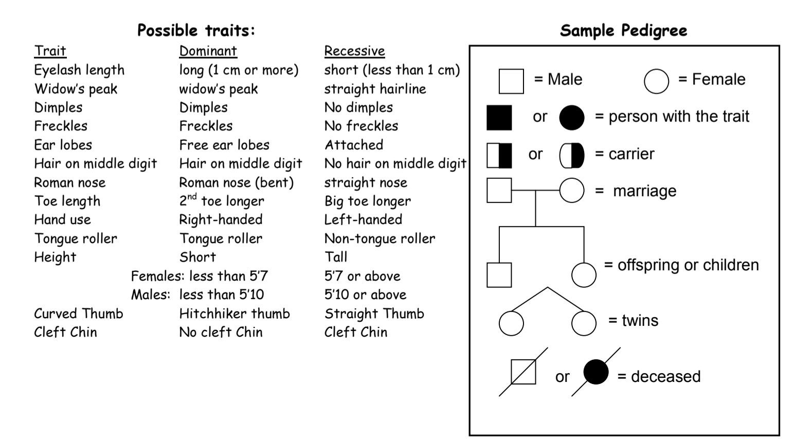
Adapted from: https://drive.google.com/file/d/0B02EyhfdV7ZabGt6a2ZpaWdieEE/view

