Magnets WebAssignment
You will need to log into discovery education.
Mad About Magnets : Please read the article and create a timeline. Please include at least 5 dates as well as an explanation of what happened on those dates. Pictures are encouraged. = ) (Remember BC is before AD!!!!)
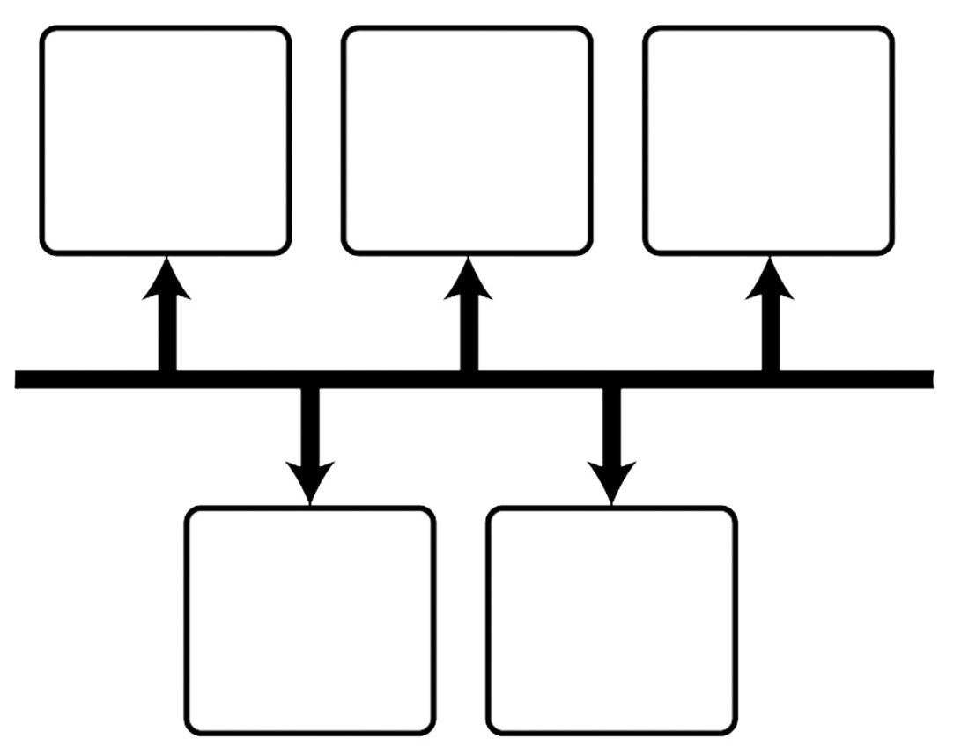
Timeline about: _________________________________

- Everyday uses for magnets: Please watch the video clip and list three everyday uses for a magnet.
  - ________________________________
  - ________________________________
  - ________________________________

- What is a Magnet?
  - Define the following vocabulary words.
    - Magnet: _________________________________________ _______________________________________________
    - Force: __________________________________________
    - Attract: _________________________________________
    - Repel: __________________________________________
  - What is a magnetic field?

  - Where is a magnetic field strongest?

- Animal Magnetism: Please watch the video clip and list four interesting facts.

- Attraction is Mutual: Use the simulation online to help fill in the chart below.
Magnet Arrangement | Sketch a picture of what happened.
North, North, North
North, South, North
South, North, North
South, South, North
No magnet, North, North
No Magnet, South, North

Conclusion: Based on your observations, in a complete sentence state your conclusion.

