Name _____________________________________________________ Date ________________ Page _____

**The Excretory System – “Removing Poisons and Solid Wastes”**

**Excretory System**

**Functions=**

**2. Types of Wastes Products**

**Lungs**

**Rectum**

**Liver**

**Skin**

**1.Kidneys**

**Fun Facts**

1. The body has approximately 2 - 4 million sweat glands weighing a total of approximately 100 grams (about 3 ounces).
2. The most concentrated area of sweat glands is on the bottom of our feet while the least concentrated area of sweat glands is on our back.
3. Women have more sweat glands than men, but men's are more active.
4. When a male passes gas, it usually measure about 1/2 cup. A woman usually passes 1/3 cup of gas.
5. The average person passes gas about 10 times per day.
6. Holding in gas is dangerous! Methane and other gases can be forced to reenter the bloodstream and these are poisonous to the body.
7. Cirrohsis is a disease of the liver and can be caused by drinking too much alcohol.

**The Excretory System – “Removing Poisons and Solid Wastes”**

C:\Users\Shannon Taylor\AppData\Local\Microsoft\Windows\Temporary Internet Files\Content.IE5\VON6CJCX\MC900320224[1].wmfOur excretory system is responsible for removing the waste products that our body makes when digesting food, using oxygen, and taking in chemicals (medicines/drugs). If our excretory system didn’t exist, poisons would quickly build up in our bodies and death would happen quickly. The main fuctions of the excretory system are to rid the body of wastes, maintain the correct amount of water and salt in the body, and make sure the pH (acidity) of the blood remains constant. Several organs work together to rid our bodies of different types of wastes.

1. **Kidneys:** Your body has two kidneys, located in your lower back. The kidneys are responsible for cleaning the blood. Each kidney is made up of one million nephrons which act as small filters. These filters remove the wastes from the blood and return the clean blood back to the bloodstream. The kidneys remove extra water, salts, urea (made during digestion), and ammonia. This liquidy waste is called urine and is stored in the bladder until it is time to go to the bathroom.
2. 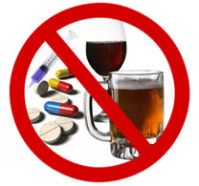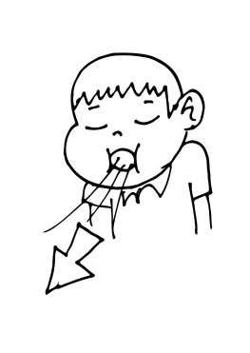**Lungs:** Your body has two lungs, located in your chest. The lungs are responsible for cleaning the blood of gaseous waste. Each lung is made up of many alveoli which act as thin sacs where air can move in and out of the blood. While healthy oxygen (O2) gas moves into the blood, poisonous carbon dioxide gas (CO2) is released from the blood. Carbon dioxide gas is created when the body’s cells convert glucose into energy. If the body cannot get rid of this poisonous gas, the cells will begin to die.
3. **Liver:** Your largest internal organ is the liver. Your liver is located just above your stomach. The liver works closely with the digestive system to make bile which is used to digest your food. However, the liver also works closely with the excretory system to remove waste products from the blood. The liver removes wastes from the blood that includes toxins from alcohol, medicines, and drugs.

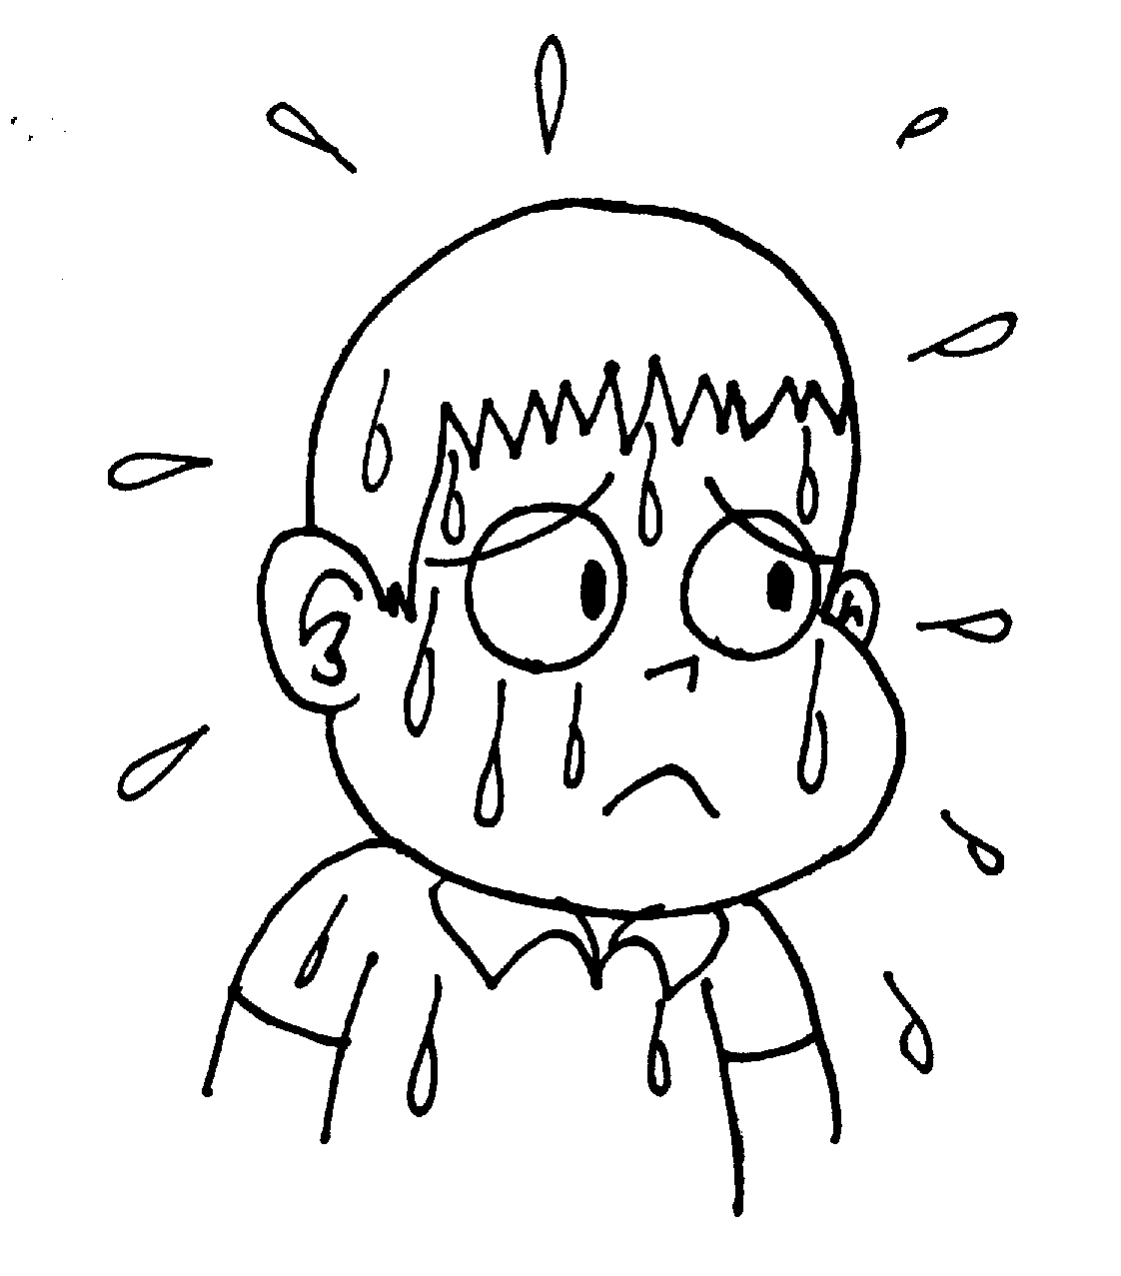

1. **Skin:** Your largest external organ is the skin. The skin contains numerous sweat glands that release water and other substances when the body becomes too warm. When the water evaporates from the skin, the temperature goes down and the body cools. In addition to water, sweat contains urea and salts that have built up in the blood.



1. **Rectum:** The rectum is the last section of the large intestine. The rectum contains muscles that hold the solid wastes from undigested food until it is time to go to the bathroom. Solid wastes is mostly food that was eaten and not needed by the body or cannot be broken down.