Name: _________________________
Pedigree Charts

A pedigree for any family, be it dogs, cats or humans, shows the pattern of inheritance in a family for a specific trait. Males are shown as squares and females are shown as circles. Each generation is shown as a Roman numeral and each person in a generation is numbered. The trait that is being expressed is shown as a shaded shape.
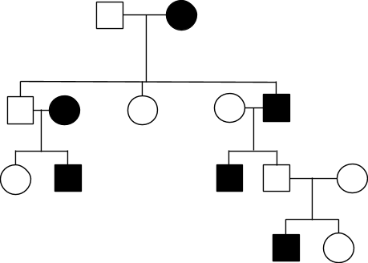
Observe the pedigree. Number the generations and each person on the pedigree.

In this family, how many individuals show the trait? ________________

Which males show the trait? (generation,number)
Determining genotypes
N = normal feet, n = webbed feet. Write down the genotypes of each individual under him/her.
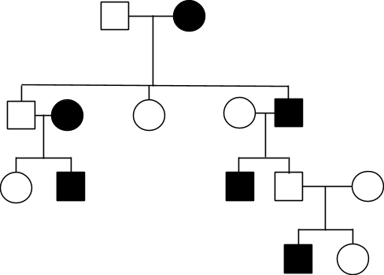
Can you determine the genotype of individual IV,2? Explain why or why not
________________________________________________________________________________________________________________________________________________________________________________
Use the information and the pedigree to answer the following questions.
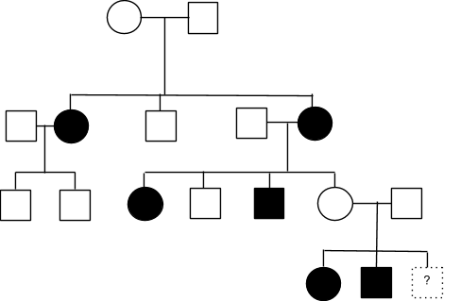
In monsters, the allele for having one eye is dominant (A). The allele for two eyes is recessive (a). The pedigree shows the occurrence of one eye and two eyes in four generations of a family.

Label the generations and individuals
Answer the following questions.
1. Which of these individuals in the pedigree is a male with the genotype aa?

a. Individual I-1
b. Individual II-2
c. Individual III-2
d. Individual III-5

2. Individuals III-6 and III-7 have two little monsters and are expecting a third one. Their two children have two eyes. What is the chance that the third child will have one eye?

a. 25%
b. 50%
c. 75%
d. 100%

3. Show how you answered question 2 with a Punnett square.
4. Complete each of the following Punnett squares 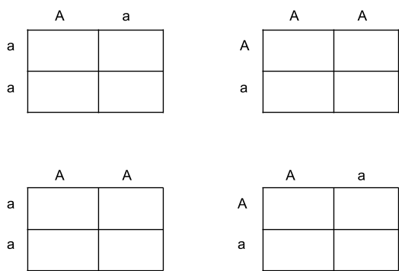
5. Circle the Punnett square shows the cross between Individual II-4 and Individual II-5.

