Anticipation Guide
Directions:
1. Respond to each statement below before the activity with a “T” for true or a “F” for false.
2. Complete the activity
3. Respond to each statement after the activity with a “T” for true or a “F” for false.
4. Rewrite the statements that are false so that they are true.
Before |  | After
 | 1. The total amount of water on Earth is always the same.
 | 2. The water cycle is driven by the moon.
 | 3. Precipitation is any type of liquid or solid water that falls to Earth's surface.
 | 4. The hydrosphere is all of the water in the rivers and lakes.
 | 5. Clouds form through the process of evaporation.
 | 6. Water moving between the oceans and the atmosphere influence our weather patterns.
 | 7. Condensation of water causes the air to get warmer and this is important in the formation of tornadoes.
 | 8. Water vapor is water in the form of a gas in the atmosphere.
Rewrite the false statements below:

Anticipation Guide
Directions:
1. Respond to each statement below before the activity with a “T” for true or a “F” for false.
2. Complete the activity
3. Respond to each statement after the activity with a “T” for true or a “F” for false.
4. Rewrite the statements that are false so that they are true.
Before |  | After
 | 1. The total amount of water on Earth is always the same.
 | 2. The water cycle is driven by the moon.
 | 3. Precipitation is any type of liquid or solid water that falls to Earth's surface.
 | 4. The hydrosphere is all of the water in the rivers and lakes.
 | 5. Clouds form through the process of evaporation.
 | 6. Water moving between the oceans and the atmosphere influence our weather patterns.
 | 7. Condensation of water causes the air to get warmer and this is important in the formation of tornadoes.
 | 8. Water vapor is water in the form of a gas in the atmosphere.
Rewrite the false statements below:

Background Information
Water is always cycling between the land to the air and back again. This process is known as the water cycle.
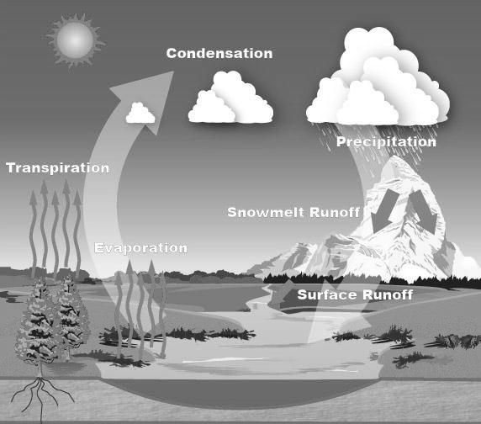
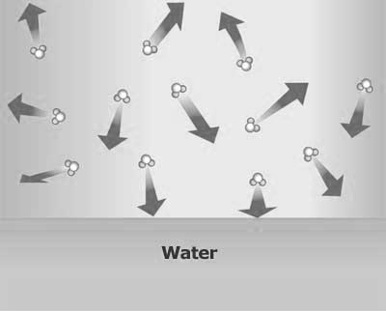
The water in the atmosphere comes from the Earth’s surface water. Surface water evaporates (changes from a liquid to a gas) and becomes water vapor. Water vapor is water in the atmosphere. Water vapor is invisible and is in the form of a gas.
Most of the water in the atmosphere comes from the oceans, especially from tropical oceans. Wind moves the water vapor to cooler areas where the water vapor may condense (change from a gas to a liquid) and form precipitation. Precipitation is any type of water that falls to Earth’s surface such as rain, snow and sleet.
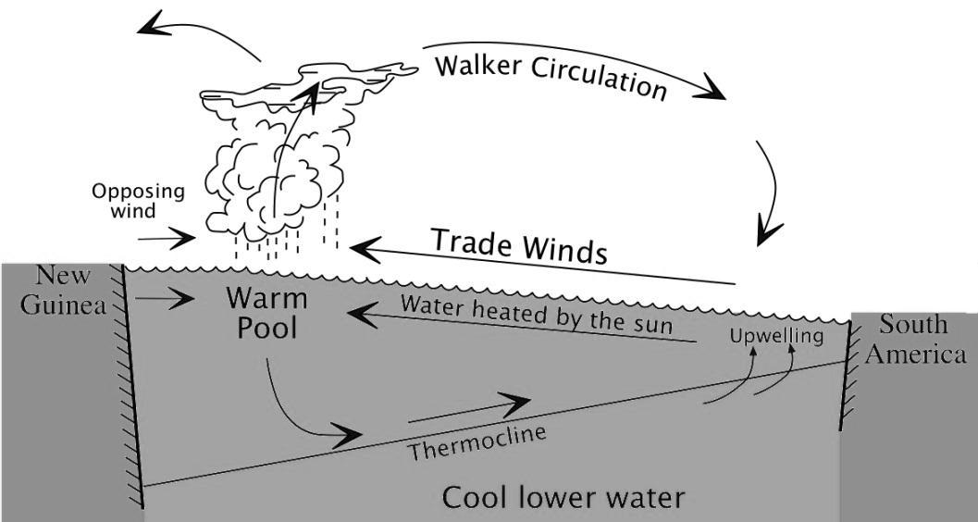

Precipitation is due to condensation. Condensation does not occur at one particular temperature. It is due to a difference between two temperatures; the air temperature and the dew point temperature. The dew point is the temperature at which water vapor will start to condense out of the air as liquid water.
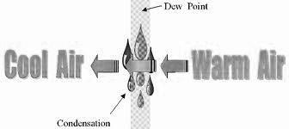
When water evaporates, it takes in heat energy from the air causing the air around it to cool down. This is one reason why the air is cooler by the beach in the summer time. As water condenses, the water releases heat and warms up the air around it. The release of heat energy during condensation is a factor in the formation of hurricanes. The exchange of heat energy that occurs during evaporation and condensation affects wind patterns and the weather.
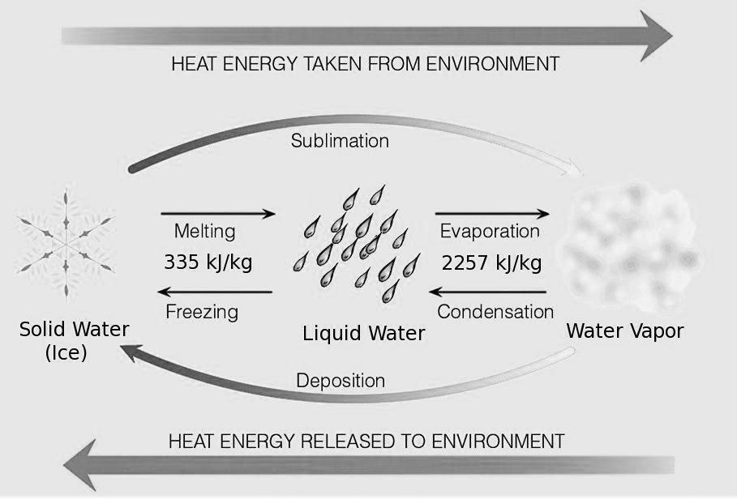
*Sublimation is when water changes from a solid (such as ice and snow) directly into a gas. This usually only happens at high altitudes.
*Deposition is when water vapor changes directly from a gas to a solid. This occasionally occurs in clouds when snowflakes are formed or when frost collects on the grass on cold mornings.
“Most of the thermal energy at the Earth’s surface is stored in the Ocean. The ocean and atmosphere work together to move heat and fresh water across the globe. Wind-driven and ocean current circulations move warm water toward the poles and colder water toward the equator. Thus, the absorption and movement of energy on the Earth is related to the ocean and atmosphere working together as a system.” (http://oceanservice.noaa.gov/education/pd/oceans_weather_climate/energy_oceans_atmosphere.html, 2012)
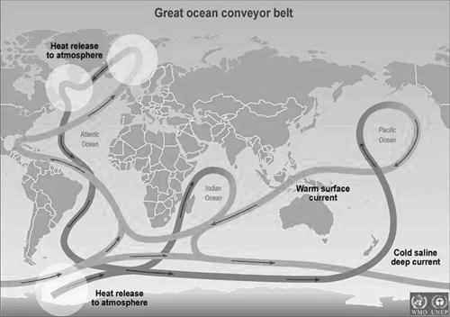
Water vapor in the atmosphere does not only come from the oceans. It also comes from other sources such as rivers, streams and transpiration. Transpiration is when water is released to be evaporated from the leaves of plants. This occurs when plants go through photosynthesis. Transpiration accounts for 10% of the water vapor in the atmosphere.
High in the atmosphere, gaseous water (water vapor) cools down, condenses and turns into clouds. When molecules of water in clouds collect into big enough drops, they fall on us as rain, snow, sleet or hail depending on the temperature. Rain, snow, sleet and hail are types of precipitation. Sometimes clouds form on the ground and form fog. Fog forms when moist air suddenly drops in temperature and condenses.
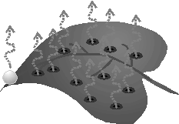
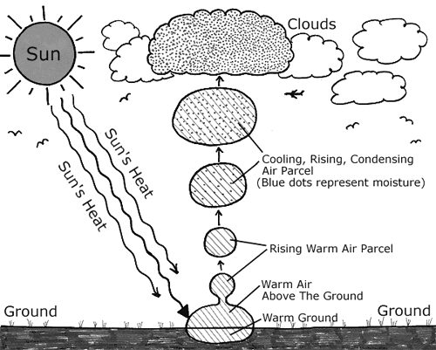
http://www.nc-climate.ncsu.edu/edu/k12/.WhyCloudsForm
When water falls back to earth, some of the water infiltrates or sinks into the ground and becomes ground water. Other water flows on the surface of the Earth and is called runoff. Eventually, the runoff from the continents returns to the oceans completing one turn of the water cycle. The same water has been cycling on Earth for billions of years.
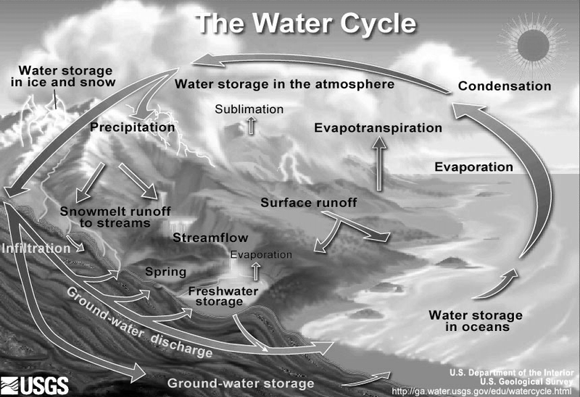
http://ga.water.usgs.gov/edu/watercycle.html
Fun Facts:
*The length of time an average water molecule stays in the atmosphere is 9 days.
*The length of time an average water molecule stays in the ocean is 3200 years.
There is a fixed amount of water on Earth that is constantly moving and changing forms through the water cycle. All of this water is known as the hydrosphere. Even though water is constantly moving through the hydrosphere, the amount of water in the atmosphere and on the Earth’s surface is always the same. 97% of the Earth’s water is in the oceans and only 3% of the Earth’s water is fresh water. “Although the atmosphere may not be a great storehouse of water, it is the superhighway used to move water around the globe.” (U.S Geological Survey, 2012). The water cycle is a continuous process that never ends. This is important because water is the most important molecule on our planet. All life on Earth is dependent on a clean supply of water.
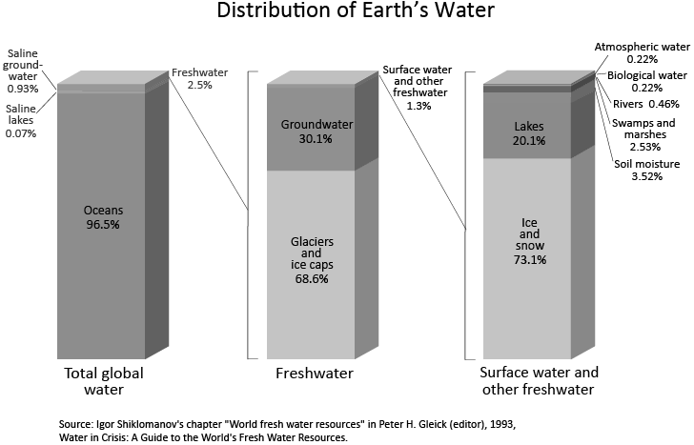
Understanding the water cycle is an important part of understanding our weather and weather patterns. The sun’s heat energy drives the water cycle by causing evaporation. The cycling of water in and out of the atmosphere is the main cause of weather patterns on Earth. Weather is the state of the atmosphere at a given time and place. Weather includes the amount of water vapor in the atmosphere, the amount and type of clouds, rain, snow, and other types of precipitation.
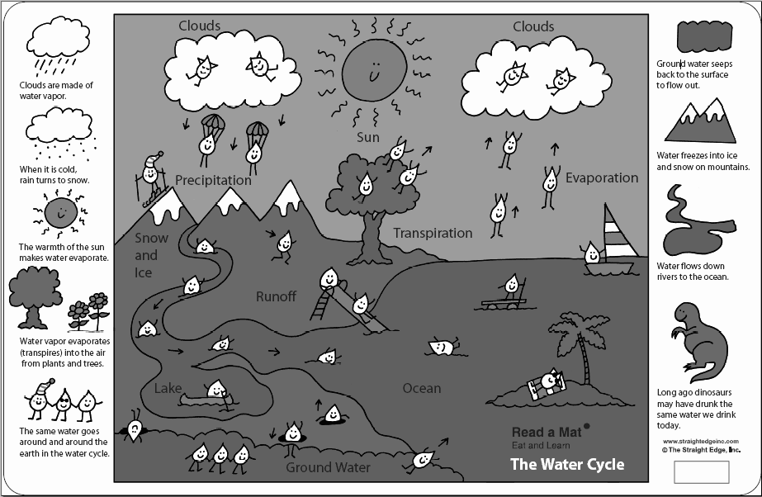
Weather is studied and predicted by scientists called Meteorologists. The science of meteorology is the study of the entire atmosphere, including the weather. To understand and predict the weather, meteorologist must first understand how the atmosphere heats and cools, how clouds form and produce rain, and what makes the wind blow.
Source: http://www.brainpop.com/science/earthsystem/watercycle
Source: http://ga.water.usgs.gov/edu/watercycleatmosphere.html
Source: http://ga.water.usgs.gov/edu/watercycle.html
Source: http://oceanservice.noaa.gov/education/pd/oceans_weather_climate/welcome.html
Source: http://www.srh.noaa.gov/jetstream/atmos/hydro.htm
Source: http://oceanservice.noaa.gov/education/pd/oceans_weather_climate/energy_oceans_atmosphere.html

Water Cycle Vocabulary
Word | Definition
Weather
Weather patterns
Meteorologist
Water Cycle
Hydrosphere
Evaporation
Condensation
Sublimation
Deposition
Precipitation
Dew Point
Fog
Transpiration
Water vapor
Run Off
Ground Water
Water Cycle Vocabulary
Word | Definition
Weather
Weather patterns
Meteorologist
Water Cycle
Hydrosphere
Evaporation
Condensation
Sublimation
Deposition
Precipitation
Dew Point
Fog
Transpiration
Water vapor
Run Off
Ground Water
Water Cycle Vocabulary
Word | Definition
Weather | The condition of Earth's atmosphere at a particular time and place
Weather patterns | Weather that repeats itself in a predictable way.
Meteorologist | A scientist who studies the atmosphere, weather and climate
Water Cycle | The repeating processes that move water in different forms between Earth's surface and the atmosphere
Hydrosphere | All of the Earth’s water that is cycling within the water cycle.
Evaporation | The process of a liquid changing into a gas
Condensation | The process of a gas changing into a liquid
Sublimation | The process of water changing from a solid directly into a gas.
Deposition | The process of water vapor changing from a gas directly into a solid.
Precipitation | Any type of liquid or solid water that falls to Earth's surface.
Dew Point | The temperature at which water vapor will start to condense out of the air as liquid water.
Fog | Clouds that form at the surface of the Earth.
Transpiration | The process of water evaporating from the leaves of plants during photosynthesis.
Water vapor | Water in the atmosphere that is in the form of a gas.
Run Off | Water that flows across the surface of the Earth.
Ground Water | Water that has infiltrated (sunk) into the ground.

Water Cycle and the Weather Think-Tac-Toe
Complete three squares in a row of your choice. Show your teacher each activity after you complete it and the teacher will initial the box if the work is complete and high quality.
Weather Patterns in the news: Find a current events article related to weather patterns that contains at least one of the vocabulary words. You may use a newspaper, magazine, or an online news sources such as CNN.com, MSN.com etc… Highlight the vocabulary words in the article. Write a summary of the article. | Make an illustrated children’s pop- up book about the water cycle and how it affects our weather. | Make a poster that demonstrates how the water cycle affects our weather.
Create and perform a play or make a video about a drop of water that goes through the water cycle during a time period of your choice in history. Keep in mind, that the same water has been cycling on Earth for billions of years. | Free Space | Make a power point presentation about the history of weather forecasting.
Write a poem, song or rap that teaches the water cycle. Include at least 4 of the vocabulary words in your creation. | Make a crossword puzzle that includes at least 5 of the vocabulary words. | Come up with your own idea for a project. Ask your teacher for approval before beginning.

Water Cycle and the Weather Think-Tac-Toe
Complete three squares in a row of your choice. Show your teacher each activity after you complete it and the teacher will initial the box if the work is complete and high quality.
Weather Patterns in the news: Find a current events article related to weather patterns that contains at least one of the vocabulary words. You may use a newspaper, magazine, or an online news sources such as CNN.com, MSN.com etc… Highlight the vocabulary words in the article. Write a summary of the article. | Make an illustrated children’s pop- up book about the water cycle and how it affects our weather. | Make a poster that demonstrates how the water cycle affects our weather.
Create and perform a play or make a video about a drop of water that goes through the water cycle during a time period of your choice in history. Keep in mind, that the same water has been cycling on Earth for billions of years. | Free Space | Make a power point presentation about the history of weather forecasting.
Write a poem, song or rap that teaches the water cycle. Include at least 4 of the vocabulary words in your creation. | Make a crossword puzzle that includes at least 5 of the vocabulary words. | Come up with your own idea for a project. Ask your teacher for approval before beginning.

